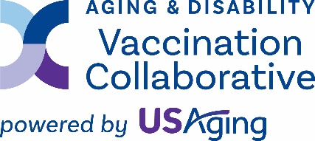
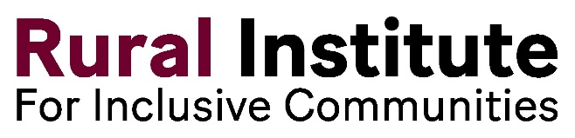

For more information, contact Tannis Hargrove ADVC/Rural Institute for Inclusive Communities University of Montana 243 Corbin Hall Missoula, MT 59812 (406) 243-4860 tannis.hargrove@mso.umt.edu

Effort under way in Western Montana to vaccinate people with disabilities and the elderly
An effort is under way in Western Montana to remove common barriers preventing older adults, people with disabilities and other vulnerable populations from getting vaccinated for COVID-19 and influenza, as well as respiratory syncytial virus, pneumonia and shingles.
“People with disability experience significant barriers when attempting to access healthcare, information and services if those services are not designed to consider their preferences, needs and disability,” said Tannis Hargrove, of the Aging & Disability Vaccination Collaborative at the University of Montana’s Rural Institute for Inclusive Communities. “Ingrained socioeconomic disadvantages and other roadblocks still exist and are now widely recognized as major contributors to health disparities experienced by people with disability and the older population.”
The project will sponsor events and activities that will make vaccinations more accessible for people with disabilities and older adults. These include vaccine clinics, transportation to and from clinics, in-home vaccinations, and outreach and education.
The Western Montana effort is funded by the Aging & Disability Vaccination Collaborative (ADVC) at USAging, an agency that was funded for a similar national vaccination project by the U.S. Department of Health and Human Services’ Administration for Community Living.
The Rural Institute’s ADVC is partnering with Western Montana’s two centers for independent living, Summit Independent Living and Ability Montana, serving 21 Western Montana counties. These counties include Lincoln, Sanders, Mineral, Ravalli, Missoula, Lake and Flathead, which are served by Summit Independent Living, and Beaverhead, Madison, Silver Bow, Deer Lodge, Powell, Granite, Jefferson, Lewis and Clark, Broadwater, Meagher, Wheatland, Gallatin, Park, and Sweet Grass, served by Ability Montana.
Ability Montana and Summit Independent Living are non-profit organizations and two of four centers for independent living in Montana, with a mission to promote independence and advocate for people living with disabilities, including older adults. Services include workshops, classes and groups, peer mentoring, personal assistance services, youth programs, recreation programs, and technology and accessibility tools. The centers also offer training for independent living skills and self-advocacy.
In recognition that people with disability experience more severe COVID-19 cases than people without disability, and experience more barriers to wellness generally, independent living specialists in the 21 counties are preparing to have conversations with independent living clients in the region, referred to as consumers.
“It can be tough talking with consumers about why they should consider getting vaccinated,” a project information sheet explains to independent living specialists. “Some consumers may believe vaccines are harmful, while other consumers may want to be vaccinated but don’t know where to get it, how to get it, or how to afford it.” The information sheet says consumers may have access needs to be able to receive any vaccine, “such as a need for sign language interpreters, screen reader-accessible vaccine registration websites, or wheelchair-accessible transportation.”
Conversations with consumers who may ask why they should be vaccinated will be comprehensive. “Getting vaccinated is the best way to reduce your risk of getting very sick if you do get these diseases,” according to materials associated with the project. “The people most at risk for getting very sick from these diseases are older adults, people with disabilities and people who have compromised immune systems or health conditions such as asthma, diabetes or heart and lung diseases.”
Information about COVID-19 booster vaccines will be comprehensive.
Consumers who believe the COVID-19 virus is an event of the past will be educated otherwise. As 2023 ended in Montana, an average of 18 people were being admitted daily to hospitals due to severe COVID symptoms.
Consumers will be informed to bring their insurance card to vaccine sites and clinics, but are also educated about how to receive various vaccines for free, if the consumer is uninsured or underinsured. This includes the U.S. CDC’s Bridge Access Program (Bridge Access Program | CDC).
Disease-specific education will also occur, including about respiratory syncytial virus, commonly thought to be contracted only by infants and children. Education will also occur about Long COVID, an extended period of post-disease symptoms experienced by some people who’ve contracted COVID-19.
Including the independent living centers in Western Montana, other project partners include MonTech, a University of Montana program providing technology, support and services to Montanans with disabilities; UM’s Skaggs School of Pharmacy; UM’s School of Physical Therapy and Rehabilitation Science; and The Partnership for Inclusive Disaster Strategies (The Partnership for Inclusive Disaster Strategies).
UM pharmacy students will assist with outreach, and will be on hand at various clinics to answer questions, including about the efficacy and safety of vaccines, including COVID-19 vaccines and boosters, and possible side effects related to the various vaccines. This information will include the fact that hundreds of millions of Americans have safely received seasonal flu and COVID vaccines and that the vaccines do not cause disease.
Other prospective partners will include Area Agencies on Aging, the Montana Public Health Institute, local emergency planning committees, federally qualified health centers, long-term care providers, public health departments, Urban Indian Centers, and Montana’s tribes.

-30-

