A remedy for COVID-19’s disproportionate impact on older adults and individuals with disabilities By Karen Sullivan
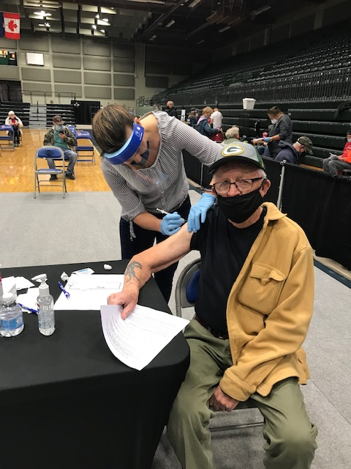
Because he was in his 80s, Butte’s Tim Shea Sr. was among the first Montanans to receive a COVID-19 vaccine, in January 2021.
COVID-19. It’s still a thing.
Since the 2023-2024 respiratory season began Oct. 1, 2023, 77 Montanans have died due to COVID, and close to 700 COVID hospitalizations have occurred.
The severe acute respiratory syndrome coronavirus 2, more commonly referred to as SARS-CoV-2, reared its proverbial ugly head in Montana exactly four years ago, in March 2020. We here in Butte-Silver Bow were notified by Montana state officials March 13, 2020 – Friday the 13th to be precise – that our county had one of the state’s first four COVID cases.
We have learned so much since then. One reinforced lesson is COVID-19 has a disproportionately negative impact on older adults and individuals with disabilities.
“Despite previous vaccination efforts, seniors remain at heightened risk of severe outcomes from COVID-19, including hospitalizations and fatalities,” according to an article published recently by Medriva (https://medriva.com/), a website with a mission to deliver accurate and up-to-date medical news. “This vulnerability is amplified by the fact that immunity, whether from past infection or vaccination, tends to diminish more rapidly in seniors.”
And this from the U.S. Centers for Disease Control and Prevention: “People with certain disabilities have a higher risk of getting respiratory virus-related complications … for example, during the first two COVID-19 pandemic waves, people with intellectual disabilities were equally as likely as other people to become infected but had 3.5 times the risk of death.”
And from Tannis Hargrove, of the Aging and Disability Vaccination Collaborative at the University of Montana’s Rural Institute for Inclusive Communities. “People with disability experience significant barriers when attempting to access healthcare if the system isn’t designed to consider their preferences, needs and disabilities. Ingrained socioeconomic disadvantages and other roadblocks, including transportation to vaccine sites, still exist and are now widely recognized as major contributors to health disparities experienced by people with disabilities and older adults.”
Four years on, the original COVID-19 virus has transitioned into new variants many times over, with novel variants, such as the JN.1, continually emerging. In this viral morphing arena, staying protected becomes greatly important, particularly for our vulnerable elderly and disabled populations.
In recognition of the particular threat to the elderly, the CDC recently recommended an additional COVID-19 booster shot this spring for those ages 65 and older.
Fortuitously, an effort is under way in Western Montana to remove common barriers preventing older adults and people with disabilities from getting vaccinated for COVID-19. The project features vaccine clinics, transportation to and from clinics, in-home vaccinations, and outreach and education. Vaccinations preventing other diseases are also available, including those related to influenza, respiratory syncytial virus, pneumonia and shingles.
The effort is funded by the Aging and Disability Vaccination Collaborative at USAging (https://usaging.org), an agency that was funded for a similar national vaccination project by the U.S. Department of Health and Human Services’ Administration for Community Living.
Because of this funding, the University of Montana’s Rural Institute for Inclusive Communities has established its own vaccine collaborative, and is partnering with Western Montana’s two centers for independent living, Summit Independent Living and Ability Montana, serving 21 Western Montana counties. Ability Montana and Summit Independent Living are non-profit organizations and two of four centers for independent living in Montana, with a mission to promote independence and advocate for people living with disabilities, including older adults.
With supervision, UM pharmacy students are administering the project’s vaccinations and assisting with outreach. The students are also on hand at various clinics to answer questions, including questions about the efficacy and safety of vaccines, and possible side effects.
Those receiving vaccinations are asked to bring their insurance card to vaccine sites and clinics, but are also educated about how to receive various vaccines for free, if they are uninsured or underinsured. This includes the CDC’s Bridge Access Program (Bridge Access Program | CDC).
For more information on the project – particularly the value of the spring COVID-19 booster vaccine – or to bring a vaccination clinic to your community, please contact Ms. Hargrove at (406) 243-4860 or 406-539-3645 or at tannis.hargrove@mso.umt.edu.
Karen Sullivan retired in November 2021 as Butte-Silver Bow’s public health officer. She is currently working on this effort with the Aging and Disability Vaccination Collaborative at UM’s Rural Institute for Inclusive Communities.

