The University of Montana

Institutional Biosafety Committee

Manual for the Shipment of
Category A Infectious Substances,
Category B Biological Substances,
Genetically-Modified Materials,
and Dry Ice

Updated January 4, 2012

Special Thanks to Andy Glode & David R. Gillum
University of New Hampshire-Office of Environmental Health and Safety
for the original organization of the material in this document
Table of Contents

I. Introduction 3

II. Training Requirements 3

III. Shipping Overview 4

IV. Shipment Types 4
A. Category A Infectious Substances 4
1. Packaging .5
2. Labeling 5
B. Category B Biological Substances 8
1. Packaging .8
2. Labeling 8
C. Genetically Modified Organisms or Microorganisms 10
D. Unregulated biologicals, non-hazardous materials 10

V. Packaging Biological Materials 11
A. Triple Packaging 11
B. Other Packaging Requirements 13

VI. Shipper’s Declaration for Dangerous Goods .....................................................................13

VII. Select Agents 15

VIII. Shipping Company Restrictions 15

IX. International Shipments 15

X. Exporting from the United States 20

XI. Importing into the United States 20

XII. United States Postal Service Mailings 20
A. Mailing Category B Biological Substance 21
B. Mailing Exempted Human and Animal Specimens 21
C. Mailing Non-Regulated Materials 21

Classification Flow Chart 22

Appendix A Manufacturers of Certified Shipping Containers for Infectious
Substances; Diagnostic Specimens & Dry Ice 23
Appendix B Examples of Category A Infectious Substances 24
Appendix C Shipper’s Declaration for Dangerous Goods Guide 25
Appendix D Example Shipper’s Declaration for Dangerous Goods 26
Appendix E APHIS Plant Pathogens, HHS Select Infectious Agents & USDA
High Consequence Livestock Pathogens/Toxins 27
Appendix F Exclusions for HHS Select Agents/USDA High Consequence
Livestock Pathogens &Toxins 30

I. Introduction

The University of Montana (UM) Institutional Biosafety Committee (IBC) is providing this manual to assist in the shipment of biological materials and dry ice. This document includes information about how to properly classify, package, mark and label your shipment. This manual also describes the requirements necessary to ship biological materials and dry ice.

Infectious substances, diagnostic specimens and other biological materials are regulated by governmental and non-governmental, consensus development organizations. Penalties for non-compliance with the rules are significant and could result in the following fines:
- Up to $250,000 and up to a year jail sentence for individuals
- Up to $500,000 per incident for organizations.

Several agencies regulate the shipment of biological materials including:
- International Air Transport Association (IATA).
- US Department of Transportation (DOT).
- US Public Health Service (PHS).
- Occupational Safety and Health Administration (OSHA).

Infectious substances and materials categorized as “Dangerous Goods” must always be transported according to the appropriate regulations. Carrying Dangerous Goods by hand, for example, in a vial in your pocket or in luggage, is strictly prohibited. IATA/DOT regulations cover your checked luggage, materials you carry on, or materials you carry in your pockets when you board an airplane. Persons who violate IATA regulations are subject to fines and criminal prosecution.

IATA regulations are commonly encountered since they regulate materials transported by air and are generally the most restrictive. For these reasons, this guide pays special attention to IATA protocols.

II. Training Requirements

Federal regulations require that anyone wishing to ship biological materials or dry ice must first have shipping training. If you intend to package biological materials or dry ice for shipment or fill out a Shipper’s Declaration for Dangerous Goods form you must follow the training requirements outlined below.
A. Read this manual. This manual will provide familiarity with the general provisions relating to the regulations and detailed training in the requirements applicable to shipping infectious materials and dry ice.
B. If you are shipping human source material, you must have current bloodborne pathogens training from the UM IBC and a current Bloodborne Pathogen Plan in place. This training ensures that you are familiar with the hazards presented by infectious materials, proper handling, and emergency response procedures.
C. Always contact the UM IBC Biosafety Officer (BSO) at 243-6395 for assistance with your mailing. All packages containing infectious materials must be cleared with the BSO before mailing.

III. Shipping Overview

Follow these steps when shipping biological materials and dry ice:

A. Classify your materials for shipment. See Section IV.
B. Package, mark and label your material(s) appropriately. The shipper is directly responsible for the correct packaging and labeling of Dangerous Goods for transport. See Section V.
C. Fill out the Declaration for Dangerous Goods form. See Section VI.
D. If you are shipping Select Agents, special regulations apply. Consult Section VII.
E. If you plan on importing or exporting biological materials, special regulations apply. Consult Sections IX through XI.

IV. Shipment Types

For shipment purposes, biological materials are categorized into five classes:

- Category A infectious substances
- Category B biological substances
- Genetically modified organisms and microorganisms.
- Unregulated biologicals, non-hazardous materials

Read each section below carefully to determine how to classify a material. All samples preserved with flammable or toxic materials (e.g. ethanol or formaldehyde) require additional DOT training to be shipped appropriately. Contact the IBC Biosafety Officer (BSO) at 243-6395 for more information.

The regulations allow for a certain amount of professional judgment when classifying biological materials for shipment. IATA does not apply the “Standard Precautions” definition in regard to infectious materials (all human blood is treated as potentially infectious). For example, blood collected for routine screening by an insurance agency would not necessarily need to be treated as an infectious substance. However, blood collected to verify the diagnosis of HIV would be treated as an infectious substance. Keep this in mind when reading the definitions in the following sections. If you are still not sure how to classify a material for shipment after reviewing the following sections, contact the UM BSO (243-6395).

A. Category A Infectious Substances
Infectious substances are materials known to be, or are reasonably suspected to contain, an animal or human pathogen. A pathogen is a microorganism (including bacteria, viruses, fungi, parasites, rickettsia), proteinaceous infectious particle (prion) or recombinant microorganism (or element) that is known or reasonably expected to cause disease in humans or animals. These pathogens are assigned to Risk Group 2, 3 or 4 as determined by a risk assessment, as described by the American Biological Safety Association http://www.absa.org/riskgroups. Microorganisms that are unlikely to cause human or animal disease (Risk Group 1), confer no or very low, individual or community risk and do not have to be shipped as infectious substances.
Category A infectious substances are shipped as infectious substances affecting humans (UN2814), or infectious substances affecting animals (UN2900). Examples of Category A infectious substances are listed in Appendix B.

1. Packaging
- The triple packaging concept (explained in Section V) applies to Category A infectious substances.
- Purchase packaging compliant with IATA Packing Instruction 602. See Appendix A for a list of package suppliers. Make sure to specify if you are shipping a refrigerated sample (ice packs or dry ice).
- The maximum quantity of infectious substances that can be shipped by air in one package is 4 L or 4Kg.
- The maximum quantity that may by shipped via passenger aircraft is 50 ml or 50 g.

2. Labeling
The outer container of a Category A infectious substance shipment must display the following information:
• Shipper and recipient’s full name and address;
• Infectious substance label (Figure 2);
• UN number and the proper shipping name,
o UN2814, Infectious substance, affecting humans, or
o UN2900, Infectious substance, affecting animals;
• Net quantity and proper name of infectious substance;
• Name and telephone number of a person responsible for the shipment;
• Class 9 label (Figure 1) including UN1845 and net weight if packaged with dry ice; and
• Cargo Aircraft label, when shipping over 50 ml or 50 g (Figure 3)
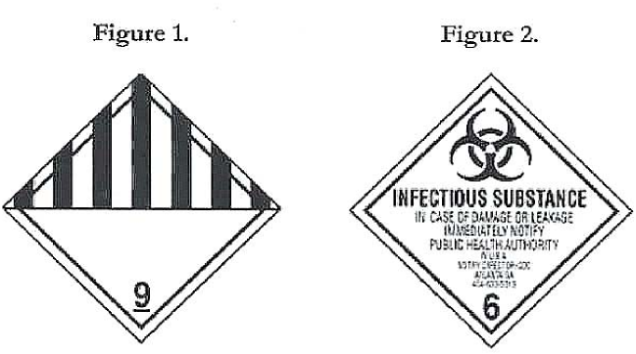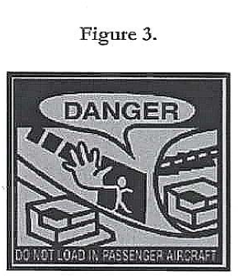
Labeling for Category A Infectious Substances
Affecting Humans

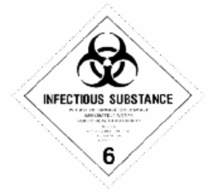
u
n
4G/Class 6.2/06/TX/ERICKSON
CONSIGNEE:
Dr. Joe Smith
78 Research Ave.
Somewhere University
Seattle, WA 98046
UN 2814 Infectious substance,
affecting humans (HIV virus cultures) 5ml
SHIPPER: Dr. Tim Jones
65 College Dr.
XYZ University
Missoula, MT 59812
Tel: Dr. Jones
406-555-9898

Shipper’s Checklist

1. Leak proof primary container
2. Absorbent material sufficient to absorb entire contents
3. Leak proof secondary container
4. Itemized list of contents
5. Outer package with UN 6.2 specification mark
6. Shipper Label
- Name
- Address
- Name of Person Responsible
- Phone number of Person Responsible
7. Consignee Label
- Name
- Address
8. Label reading: either UN 2814, infectious substance affecting humans or UN 2900, infectious substance affecting animals
- Proper name of infectious substance
- Net quantity of substance
9. Class 6 Infectious Substance sticker
10. Directional arrows on sides of package indicating top of package

Labeling for Category A Infectious Substances Affecting Humans

Packaged with Dry Ice

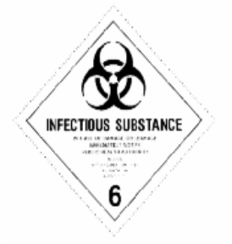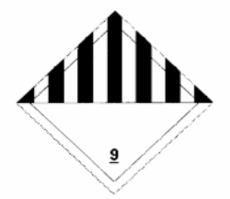
u
n
4G/Class 6.2/06/TX/ERICKSON
6.2/99/TX/ERICKSON

CONSIGNEE:
Dr. Joe Smith
78 Research Ave.
Somewhere University
Seattle, WA 98046
UN 2814 Infectious substance,
affecting humans (HIV virus infected cells), 5 ml
UN1845 Dry Ice 3 Kg

SHIPPER: Dr. Tim Jones
65 College Dr.
XYZ University
Missoula, MT 59812
Tel: Dr. Jones
406-555-9898

UN 1845 Dry Ice, 3 Kg

Shipper’s Checklist

1. Leak proof primary container
2. Absorbent material sufficient to absorb entire contents
3. Leak proof secondary container
4. Itemized list of contents
5. Outer package with UN 6.2 specification mark
6. Shipper Label
- Name
- Address
- Name of Person Responsible
- Phone number of Person Responsible
7. Consignee Label
- Name
- Address
8. Label reading: either UN 2814, infectious substance affecting humans or UN 2900, infectious substance affecting animals
- Proper name of infectious substance
- Net quantity of substance
- Dry ice and indicate amount in Kg
9. Class 6 Infectious Substance sticker
10. Class 9 Dry Ice sticker (UN 1845) indicating the amount of dry ice in Kg
11. Directional arrows on sides of package indicating top of package

B. Category B Biological Substances (infectious, diagnostic or clinical specimens)
Category B Biological Substances are infectious substances which do not meet the criteria for inclusion in Category A. Infectious substances in Category B must be assigned to UN 3373 – Biological substance category B. A Category B infectious substance does not cause permanent disability or life-threatening or fatal disease to humans or animals when exposure to it occurs

Diagnostic specimens are human or animal materials that have a relatively low probability of containing pathogens. When these materials are shipped for the purpose of screening, study or diagnosis, they are considered diagnostic specimens. These materials include human or animal tissue samples, blood, excreta, etc. Diagnostic specimens are not considered to be a hazardous material by IATA, though the following packaging and shipping requirements apply.

Note: Diagnostic Specimens must be shipped as an Infectious Substance when the source patient or animal has or may have a serious human or animal disease that can be readily transmitted from one individual to another, directly or indirectly, and for which effective treatment and preventative measures are not usually available.

1. Packaging
- Basic triple packaging (see Section V) applies to Category B infectious substances.
- Purchase packaging compliant with IATA Packing Instruction 650. See Appendix A for a list of package suppliers. Make sure to specify if you are shipping a refrigerated sample (ice packs or dry ice).
- For Category B infectious substances, the maximum quantity for a primary receptacle is 500mL or 500 g and the outer packaging must not contain more than 4L or 4 kg.
2. Labeling
The outer container of a Category B infectious substance shipment must display the following information:
• Sender and recipient’s full name and address;
• The words “Biological substance, Category B”
• UN 3373 label (Figure 4)
• Name and telephone number of a person responsible for the shipment;
• Class 9 label (Figure 1) including UN1845 and net weight if packaged with dry ice;

Figure 4
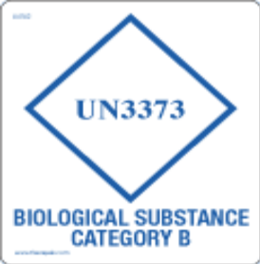

Labeling for Diagnostic, Clinical or Biological Substance Category B Samples

CONSIGNEE:
Dr. Joe Smith
78 Research Ave.
Somewhere University
Seattle, WA 98046
SHIPPER: Dr. Tim Jones
65 College Dr.
XYZ University
Missoula, MT 59812
Tel: Dr. Jones
406-555-9898

DIAGNOSTIC OR CLINICAL SPECIMENS OR BIOLOGICAL SUBSTANCE, CATEGORY B
UN3373

Shippers Checklist

1. Shipper Label
- Name
- Address
- Telephone #
- Contact person

2. Consignee Label
- Name
- Address

3 A UN3373 sticker (or equivalent)

4. Label reading: “Diagnostic or clinical specimens or Biological Substance Category B”

6. Class 9 Dry Ice sticker indicating the amount of dry ice in Kg (if dry ice is included in shipment)

C. Genetically-Modified Organisms and Microorganisms
Genetically-modified organisms or microorganisms containing genetic material that has been purposely altered through genetic engineering in a way that does not occur naturally. These substances and animals that may carry them are defined as Dangerous Goods by IATA.

A genetically-modified microorganism that meets the definition of an infectious substance must be shipped as an infectious substance. Instructions for shipping an infectious substance must be followed.

A genetically modified microorganism that is not an infectious substance but which is capable of altering animals, plants or microbiological substances in a way that is not normally the result of natural reproduction should be classified as a miscellaneous hazard (Class 9). Pack these materials as you would infectious substances, in packaging compliant with IATA Packing Instruction 913. If this packaging is not available, use packages compliant with IATA Packing Instruction 650. Affix a Class 9 label (Figure 1) if shipping on dry ice. Ship the materials using the proper shipping name, “Genetically modified microorganisms”, UN3245. The maximum allowable quantity per primary receptacle is 100 mL or 100 g. There is no maximum net quantity per package.

Genetically modified organisms that are known or suspected to be dangerous to humans, animal or the environment cannot be transported by air.

Animals that contain, or are contaminated with, genetically modified microorganisms or organisms that meet the definition of an infectious substance cannot be shipped by air.

Genetically modified materials that are not infectious and pose no risk to humans, animals or plants are not restricted for transportation. The IBC recommends that you take the extra step and use a triple packaging arrangement.

D. Unregulated Biologicals, Non-hazardous Materials

If the biological material definitely cannot cause disease, Dangerous Goods Regulations do not apply. For example, purified enzymes, a sterilized bone specimen, and non-pathogenic bacteria (Risk Group 1 agents) all would not have specific shipping instructions. Do not designate a material as non-hazardous until you read through all the classification schemes presented in this manual. The IBC recommends that you take the extra step and use a triple packaging arrangement (as detailed in Package instructions 650, especially if you are shipping liquids), but it is not mandatory. Use common sense and package the material to protect it from breakage during handling and shipping.

The materials listed below are not subject to IATA or DOT infectious regulations. However, these materials may require a permit for shipment abroad. All shipments of blood and blood products must be labeled with a biohazard symbol.
• Substances which do not contain infectious substances or which are unlikely to cause disease in humans or animals;
• Non-infectious biological material from humans, animals or plants. Examples include non-infectious cells, tissue cultures, blood or plasma from individuals not suspected of having an infectious disease, DNA, RNA, or other genetic elements;
• Substance containing microorganisms which are non-pathogenic to humans or animals;
• Substances that have been neutralized or inactivated such that they no longer pose a health risk;
• Environmental samples which are not considered to pose a significant risk of infection;
• Dried blood spots or fecal occult screening test;
• Blood or blood components collected for the purpose of transfusion or the preparation of blood products to be used for transfusion or transplantation;
• An infectious substance, other than a Category A infectious substance, contained in a patient sample being transported for research, diagnosis, investigational activities, or disease treatment and prevention, or a biological product, when such materials are being transported by a private or contract carrier in a motor vehicle used exclusively to transport such materials;
• Tissue or organs for use in transplantation,
• A material with a low probability of containing an infectious disease or where the concentration of the infectious substance is at a level naturally occurring in the environment so it cannot cause disease when exposure to it occurs. Examples of these materials include food stuffs and environmental samples (such as water or a sample of dust or mold) or;
• A biological product, including an experimental or investigational product or component of a product, subject to federal approval, permit, review or licensing requirements such as those required by the Food and Drug Administration or the US Department of Agriculture*.
* When mailing these items with the USPS, follow packaging guidelines for non-regulated items. See Section XII.

V. Packaging Biological Materials

Potentially hazardous biological materials must be packaged to withstand leakage of contents, shocks, temperature, pressure changes and other conditions that can occur during ordinary handling in transportation. Packaging material(s) appropriately is accomplished by purchasing certified packaging. Refer to Appendix A for vendors that can supply certified packaging for biological materials. The shipper is directly responsible for the correct packaging and labeling of Dangerous Goods for transport. When ordering, specify what category of material(s) you will be shipping: infectious substances, diagnostic specimens, dry ice, icepacks, etc. The varying categories meet different packaging criteria, but all follow the basic triple packaging requirements described below.

A. Triple Packaging
Biological materials falling under the Dangerous Goods Regulations must be packaged according to the triple packaging principle depicted in Figure 5. The three elements of triple packaging include: Primary receptacle, leak-proof secondary container, and durable outer container. Infectious substances, diagnostic specimens and genetically modified microorganism must be packaged in this way, with slight variations.

Figure 5. Packaging and labeling of biological materials
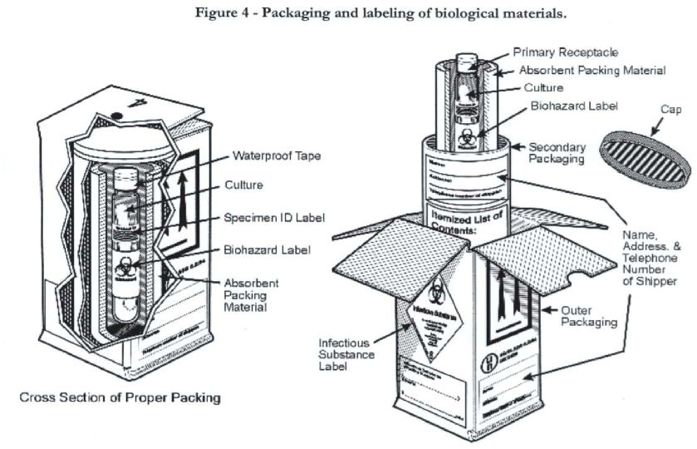
The primary container holds the biological material
- Must be leak-proof.
- Must be labeled with the name of the contents.
- A leak-proof seal, such as a heat seal, skirted stopper or metal crimp, is required.
- If the container has a threaded lid, it must be secured with waterproof tape.
- Do not use Petri plates as primary receptacles.
- Lyophilized substances can only be shipped in flame sealed glass ampoules or rubber-stoppered glass vials with metal seals.
- Packaging purchased for shipping infectious substances or diagnostic specimens usually does not include the primary container.
The secondary container holds one or more primary containers
- Must also be leak-proof.
- This container must meet specific United Nations (UN) performance standards. Containers purchased from commercial vendors are designed to meet the necessary standards.
- If you are shipping any liquid, there must be enough absorbent material in the secondary container to absorb all of the liquid in the primary receptacle(s).
- If multiple primary containers are used, they must be wrapped to prevent contact between them so they do not break during transport.
The outer container
- Must be at least 100 mm (4 inches) in the smallest overall external dimension, in order for required markings and labels to fit.
- The outer package must be of adequate strength for its capacity, mass, and intended use.
- It must also be certified with a UN specification mark.
- An itemized list of the package contents must be included between the outer and secondary container.
- The outer package should be marked to identify hazardous contents, including the proper shipping name, UN number and net quantity for each substance.

B. Other Packaging Requirements
Overpacks.
- An overpack can be used to combine several triple packages into one large package.
- This may be done to save freight charges when shipping multiple samples.
- Each triple package inside the overpack must be properly marked and labeled.
- The outside of the overpack must bear the same markings and labels as the triple packages within.
- If packed with dry ice, the total net quantity of dry ice must be listed on the outer container.
- The overpack must also be marked with the statement: “Inner Packages Comply With Prescribed Specifications.”

Ice and Dry Ice.
- If a shipment includes ice or dry ice, special packaging must be purchased.
- If shipping with ice, the packaging must be leak-proof.
- If dry ice is used, the outer packaging must allow for the release of carbon dioxide gas when the solid sublimates.
- Ice or dry ice must be placed outside the secondary packaging.
- Interior supports must be provided to secure the secondary container as the refrigerant melts/sublimates.
- Dry ice is considered a miscellaneous hazard (Class 9) by IATA.
- Packages containing dry ice must bear a Class 9 label (Figure 1) and be marked with the proper shipping name, UN number and net quantity (e.g., Dry Ice, UN1845, 3 KG).
- Certified packages for dry ice most likely will be pre-labeled and be marked.
- A Declaration for Dangerous Goods is not required for shipments in which dry ice is the only hazardous material.
- Dry ice is included on the Declaration for shipments that include other hazardous materials such as infectious substances.

Liquid Nitrogen.
- Biological materials can be shipped in liquid nitrogen or dry shippers, which are insulated packages containing refrigerated liquid nitrogen fully absorbed in a porous material.
- Special packing regulations apply to shipments containing nitrogen.
- Contact the IBC BSO at 243-6395 if you need to ship materials with liquid nitrogen.

VI. Shipper’s Declaration for Dangerous Goods

A Shipper’s Declaration for Dangerous Goods form must be completed when shipping infectious substances or genetically modified microorganisms. A Shipper’s Declaration is not required for shipments in which dry ice is the only hazardous material. Dry ice should be listed on the Declaration for shipments containing infectious substances or genetically modified microorganism. A Declaration is not required if you are shipping diagnostic specimens that are not considered infectious. The Declaration is included with purchased shipping materials, or provided by the carrier. For Federal Express, these forms must be typed or computer generated. Improperly completed Declarations are the most common cause of package refusal.

Refer to the Shipper’s Declaration for Dangerous Goods in Appendix C for an explanation of each section (see A-M below).

(A) Shipper: Enter your full name, address and telephone number.
(B) Consignee: Enter full name and address of recipient. When shipping infectious substances, include the text. “Person responsible for the shipment,” followed by the name of the responsible person and phone number.
(C) Transport Details: Indicate here if your shipment is restricted to cargo aircraft only (if it is more than 50 mL or 50 g of an infectious substance). Airport of departure and airport of destination will be filled out by the carrier, leave blank.
(D) Shipment Type: Cross out “radioactive” to indicate you are shipping a non-radioactive substance and vice versa.
(E) UN or ID Number: Enter appropriate UN number found in Table 1.
(F) Proper Shipping Name: Enter the proper shipping name exactly as it appears in Table 1 below.
(G) Class or Division: Enter appropriate hazard class as found in Table 1.
(H) Packing Group: For dry ice, enter “III” in this column. Biological materials are not assigned packing groups.
(I) Quantity and Type of Packaging: Enter the net quantity for each material here. Use only metric units. At the bottom of this column, indicate the number and type of packages used (usually, “all packed in one fibreboard box.”). Do not spell like “fiberboard.” If using an overpack, indicate here with “Overpack Used.”
(J) Packing Instructions: Enter appropriate packing instruction number. Refer to Table 1.
(K) Authorization: Leave this column blank.
(L) Additional Handling Instructions: Add any special instruction here.

(M) Signature and Date.

Declaration forms must be filled out in triplicate. Keep one copy and supply two to the carrier. Regulations require that you must retain your copy for 2 years. A completed sample declaration is found in Appendix D. Feel free to contact the IBC BSO (243-6395) with any questions on how to fill out the Shipper’s Declaration.

Table 1. Summary of Shipping Information

Shipment Type | Proper Shipping Name | UN Number | Hazard Class | Packing Group | Packing Instruction | Max. Net qty/pkg. for Passenger Aircraft | Max. Net  qt/pkg for  Cargo Aircraft
Category A Infectious substance, affecting humans and possibly animals | Infectious substance, affecting humans | UN 2814 | 6.2 | 602 | 50 ml or 50 g | 4 L or 4 kg
Category A infectious substance, affecting only animals (not humans) | Infectious substance, affecting animal | UN 2900 | 6.2 | 602 | 50 ml or 50 g | 4 L or 4 kg
Category B infectious substance | Infectious Substance, Category B | UN 3373 | 6.2 | 650 | 4 L or 4 kg | 4 L or 4 kg
Dry Ice | Dry Ice or Carbon Dioxide, solid | UN 1845 | 9 | III | 904 | 200 kg | 200 kg
Non-infectious, transducing genetically  modified organism or microorganism | Genetically modified microorganisms | UN 3245 | 9 | 913 | No limit | No
VII. Select Agents
The US Department of Health and Human Services (DHHS) and the US Department of Agriculture have developed a list of Select Agents - biological agents and toxins (Appendix E) that have the potential to pose a severe threat to public health. Special regulations apply to the use and transfer of these materials, including registration with the UM IBC, the Animal and Plant Health Inspection Service (APHIS), and/or the Centers for Disease Control and Prevention (CDC). No transfers may be made without written authorization from the IBC and completed federal registration. If you are planning to, or currently work with, any of the Select Agents listed in Appendix E, and have not registered, contact the IBC BSO (243-6395). Specific shipping restrictions apply to these agents (not discussed in this document).

VIII. Shipping Company Restrictions
Some shipping companies may have requirements that are more restrictive than those discusses in this document. Consider the following details before planning a shipment.

DHL/Airborne Express. Airborne Express has merged with DHL and will accept shipments made according to IATA or DOT regulations. Shipments made according to instructions in this manual will be acceptable to DHL.
FedEx. FedEx Express and FedEx Ground will accept shipments prepared according to instructions in this manual. FedEx will not accept any material considered to be in Risk Group 4, see Section VIII.
United States Postal Service (USPS). The USPS has highly restrictive regulations concerning the shipment of hazardous materials by mail. Diagnostic specimens may be shipped by the USPS. For more information, refer to Section XII.
UPS. UPS will not accept domestic shipments prepared according IATA regulations.

IX. International Shipments
Shipping and receiving animals and animal-derived materials, infectious or biohazardous agents, biological toxins, and genetically modified organisms may require the approval of federal agencies, both domestic and foreign. Regulations that govern the transfer of biological materials help to minimize or eliminate the possible threats to public health and agriculture.

Packages shipped internationally generally require and increase preparation time due to additional paperwork required for such packages. An import/export permit may be required when shipping biological materials internationally. Check the following U.S. governmental agencies for permits and additional information.

APHIS Agricultural Permits
http://www.aphis.usda.gov/permits/index.shtml
(Toll free: 866-524-5421)
APHIS permits are required to import or domestically transfer a plant, pest, biological agent, or other material listed below.

• Arthropods (insects and mites)
• Arthropods inhabiting dung or of medical/veterinary significance
• Bees and bee related articles
• Biological materials containing animal material
• Butterflies
• Cell cultures of bovine or other livestock origins
• Cut flowers
• Earthworms
• Endangered species
• Endangered species of wild fauna and flora
• Entomopathogens
• Farm animals
• Foreign cotton and covers
• Fruits and vegetables
• High consequence livestock pathogens and toxins
• Indian corn or maize, broomcorn and related plants
• Infectious agents of livestock
• Khapra beetle products
• Live arthropods for display or educational purpose
• Livestock
• Moths
• Noxious weeds
• Nursery stocks (including seeds)
• Parasitic plants
• Plant pathogens
• Predators and parasitoids of arthropods
• Prohibited material for research purposes
• Rice and rice related articles
• Seeds
• Snails and slugs
• Soil
• Sugarcane products and by-products (including parts of the sugarcane plant)
• Tissue culture materials of bovine or other livestock origins
• Weed biocontrol
• Wildlife
• Wood products

CDC Permit to Import or Transport Agents or Vectors of Human Disease
(www.cdc.gov/od/eaipp )
404-718-2093
CDC permits are required when shipping any infectious agent known or suspected to cause disease in humans, in sterilized specimens of human or animal tissues (including blood and other fluids), or biological vectors of infectious animals, bats, insects, arthropods, and snails.

Items Requiring Permits
- Etiologic agents It is impractical to list all etiologic agents on this website. In general, an import permit is needed for any infectious agent known or suspected to cause disease in humans.
- Biological materials Un-sterilized specimens of human and animal tissues (such as blood, body discharges, fluids, excretions or similar material) containing an infectious or etiologic agent require a permit in order to be imported.

Hosts and Vectors
- Animals. Any animal known or suspected of being infected with an organism capable of causing disease in humans may require a permit issued by CDC. Importation of live turtles of less than 4 inches in shell length and live nonhuman primates is regulated by the CDC, Division of Global Migration and Quarantine (http://www.cdc.gov/animalimportation/index.html).
- Bats. All live bats require an import permit from the CDC and the U.S. Department of Interior, Fish and Wildlife Services. The application for a CDC import permit for live exotic bats is on this website.
- Arthropods. Any living insect or other arthropod that is known or suspected of containing an etiologic agent (human pathogen) requires a CDC import permit.
- Snails. Snail species capable of transmitting a human pathogen require a permit from the Centers for Disease Control.

Packaging Requirements
Infectious materials imported into this country must be packaged to withstand breakage and leakage of contents, and labeled, as specified in the following federal regulations:
- USPHS 42 CFR Part 72 - Interstate Shipment of Etiologic Agents
- DOT 49 CFR PART 173 - Transportation of Etiologic Agents

For international shipments, the International Air Transport Association (IATA) Dangerous Goods Regulations should be consulted.

Other Permits
- United States Department of Agriculture (USDA), Animal and Plant Health Inspection Service (APHIS) permits are required for infectious agents of livestock and biological materials containing animal material. Tissue culture materials and suspensions of cell culture grown viruses or other etiologic agents containing growth stimulants of bovine or other livestock origins are controlled by the USDA due to the potential risk of introduction of exotic animal diseases into the U.S. Further information may be obtained by calling the USDA/APHIS at (301) 734-4704 (www.aphis.usda.gov/animal_health/).
- U.S. Fish and Wildlife Service permits are required for certain live animals, including bats (www.fws.gov/).
- Individuals wishing to import select agents and toxins must be registered with CDC's Select Agent Program in accordance with 42 CFR Part 73 (Possession, Use, and Transfer of Select Agents and Toxins; Interim Final Rule) for the select agent(s) and toxin(s) listed on the import permit application. Also, In accordance with 42 CFR Part 73.16(a), an APHIS/CDC Form 2 must be completed and submitted to the CDC Select Agent Program and granted approval prior to the shipment of the select agents or toxins under the import permit. Additional information can be found at www.cdc.gov/od/sap.

Exports of Infectious Materials
www.bis.doc.gov/Licensing/
The export of a wide variety of etiologic agents of human, plant, and animal diseases may require a license from the Department of Commerce.

Commerce Department – Bureau of Industry and Security (BIS)
(www.bis.doc.gov/index.htm)
A permit may be required from the Commerce Department when exporting infectious agents of human, plant, and animal disease, including genetic material and products which might be used for culture of large amounts of agents ( Commerce Control list Supplement No 1 to Part 774 Category 1, page 54- 59.

Human Pathogens and Toxins

Bacteria

• Bacillus anthracis
• Brucella abortus
• Brucella melitensis
• Brucella suis
• Burkholderia mallei (Pseudomonas mallei)
• Burkholderia pseudomallei (Pseudomonas pseudomallei)
• Chlamydia psittaci
• Clostridium botulinum
• Clostridium perfringens, epsilon toxin producing types
• Enterohaemorrhagic Escherichia coli, serotype O157 and other verotoxin producing serotypes
• Francisella tularensis
• Salmonella typhi
• Shigella dysenteriae
• Vibrio cholerae
• Yersinia pestis

Toxins

• Abrin
• Aflatoxins
• Botulinum toxins
• Cholera toxin
• Clostridium perfringens toxins
• Conotoxin
• Diacetoxyscirpenol toxin
• HT-2 toxin
• Microcystin (Cyanginosin)
• Modeccin toxin
• Ricin
• Saxitoxin
• Shiga toxin
• Staphylococcal aureus toxins
• T-2 toxin
• Tetrodotoxin
• Verotoxin
• Volkensin toxin
• Viscum Album Lectin 1 (Viscumin)

Viruses

• Chikungunya virus
• Congo-Crimean haemorrhagic fever virus
• Dengue fever virus
• Eastern equine encephalitis virus
• Ebola virus
• Hantaan virus
• Hendra virus (Equine morbillivirus)
• Japanese encephalitis virus
• Junin virus
• Kyasanur Forest virus
• Lassa fever virus
• Louping ill virus
• Lymphocytic choriomeningitis virus
• Machupo virus
• Marburg virus
• Monkey pox virus
• Murray Valley encephalitis virus
• Nipah Virus
• Omsk haemorrhagic fever virus
• Oropouche virus
• Powassan virus
• Pulmonary and renal syndrome-haemorrhagic fever viruses (Seoul, Dobrava, Puumala, Sin Nombre)
• Rift Valley fever virus
• Rocio virus
• South American haemorrhagic fever virus (Sabia, Flexal, Guanarito)
• St. Louis encephalitis virus
• Tick-borne encephalitis virus (Russian Spring-Summer encephalitis virus)
• Variola virus
• Venezuelan equine encephalitis virus
• Western equine encephalitis virus
• White pox
• Yellow fever virus

Rickettsiae

• Bartonella quintana (Rochalimea quintana, Rickettsia quintana)
• Coxiella burnetii
• Rickettsia prowasecki
• Rickettsia rickettsii

Animal Pathogens and Toxins

Bacteria
• Mycoplasma mycoides

Viruses

• African horse sickness virus
• African swine fever virus
• Avian influenza virus (certain highly pathogenic strains – see the Export Administration Regulations for more information)
• Bluetongue virus
• Foot and mouth disease virus
• Goat pox virus
• Lumpy skin disease virus
• Lassa virus
• Newcastle disease virus
• Peste des petits ruminants virus
• Porcine enterovirus type 9 (swine vesicular disease virus)
• Porcine herpes virus (Aujeszky’s disease)
• Rinderpest virus
• Sheep pox virus
• Swine fever virus (Hog cholera virus)
• Teschen disease virus
• Vesicular stomatitis virus

Genetic Elements/Genetically Modified Organisms

• Genetic elements that contain nucleic acid sequences associated with the pathogenicity of controlled microorganisms.
• Genetic elements that contain nucleic acid sequences coding for any controlled “toxins” or “sub-units of toxins”.
• Technical Note: Genetic elements include, inter alia, chromosomes, genomes, plasmids, transposons, and vectors, whether genetically modified or unmodified.
• Genetically modified organisms that contain nucleic acid sequences associated with the pathogenicity of controlled microorganisms.
• Genetically modified organisms that contain nucleic acid sequences coding for any controlled “toxins” or “sub-units of toxins”.

Plant Pathogens
Bacteria
• Xanthomonas albilineans
• Xanthomonas campestris pv. citri including strains referred to as Xanthomonas campestris pv. citri types A,B,C,D,E or otherwise classified as Xanthomonas citri, Xanthomonas campestris pv. aurantifolia or Xanthomonas campestris pv. Citrumelo.

Fungi
• Colletotrichum coffeanum var. virulans (Colletotrichum kahawae)
• Cochliobolus miyabeanus (Helminthosporium oryzae)
• Magnaporthe grisea (pyricularia grisea/pyricularia oryzae)
• Microcyclus ulei (Dothidella ulei)
• Puccinia graminis (Puccinia graminis f. sp. tritici)
• Puccinia striiformis (Puccinia glumarum)

FDA Import Permits
(www.fda.gov/ora/import/)
All food (except most meat and poultry), drugs, biologics, cosmetics, medical devices, and electronic products that emit radiation require a permit or registration before importation into the United States.

Fish and Wildlife Service Permit Station
(www.fws.gov/)
A permit may be required for transporting fish, wildlife, endangered species, or materials found in the list below.

Export

• African elephant ivory
• Animals
• Artificially propagated plants
• Asian elephant ivory
• Biological samples
• Captive-born export
• Circuses/traveling animal exhibitions
• Goldenseal
• Ginseng
• Marine mammals
• Museum specimens
• Personal pet
• Plants
• Raptors
• Trophies by taxidermist
• Wildlife

Import

• African elephant
• African elephant ivory
• African leopard
• Argali
• Asian elephant ivory
• Biological samples
• Birds
• Bontebok
• Circuses/traveling animal exhibitions
• Marine mammals
• Museum specimens
• Personal pet
• Plants
• Polar bears
• Scientific and zoological breeding or display
• Sport hunted trophy
• White rhinoceros
• Wildlife

X. Exporting from the United States
Depending on the nature of the shipment, an U.S. export permit may be required when sending your package. Additionally, an import permit may be required in the country where the package is being shipped. If your shipment requires an export permit, it must be completed and approved by the appropriate government agency prior to shipment.
Note: Packages may be opened and inspected when leaving the United States or at any time by any inspection service provided by other countries. In order to assure that your package is safely delivered to its intended destination, always consider the following:
1. If necessary, obtain an export permit from the appropriate governmental organization prior to shipment.
2. Package and label the material according to the guidelines listed in this manual.
3. Consider including a courtesy letter with the shipment.

XI. Importing into the United States
All shipments entering the United States are processed by the U.S. Bureau of Customs and Border Protection. An import permit may be required to deliver the package even if a permit is not required by the originating country. Check with the appropriate governmental organization prior to shipment of the material.
Note: Packages may be opened and inspected upon entry into the United States. In order to assure that your package is safely delivered to its intended destination, always consider the following:
1. If necessary, obtain an import permit from the appropriate governmental organization prior to shipment.
2. Package and label the material according to the guidelines listed in this manual.
3. Consider including a courtesy letter with the shipment
The importer is legally responsible for assuring that foreign personnel package, label, and ship the infectious materials according to USPHS and IATA regulations. Shipping labels containing the universal biohazard symbol, the address of the importer, the permit number, and the expiration date are also issued to the importer with the permit. The importer must send labels and one or more copies of the permit to the shipper. The permit and labels inform the U.S. Customs and Border Protection and U.S. Division of Quarantine personnel of the package contents.

XII. United States Postal Service Mailings
The United States Postal Service (USPS) does not allow Category A infectious substances to be mailed. Follow the procedures below when mailing Category B Substances, exempt patient specimens and non-regulated items.
A. Mailing Category B. Substance
Follow packaging and labeling requirements listed in Section IV (C) and note the following variations:
1. Shipments of both liquids and solid substances must be packaged in a pressure tested primary or secondary container; and
2. Category B substances may be mailed as First-Class, Priority or Express mail.

B. Mailing Exempted Human and Animal Specimens
Follow packaging and labeling requirements listed in Section IV(D) and note the following variations:
1. Inner containers and the total volume per package is limited to 500 ml or 500g;
2. Outer packaging must be rigid; and
3. Exempted specimens must be mailed as First-Class, Priority, Express, or Package Services mail.

C. Mailing Non-Regulated Materials
According to USPS regulations, specific packing instructions apply when mailing non-regulated materials. The following are examples of non-regulated biological materials:
1. Biological products not containing Category A or Category B substances;
2. Blood or blood products collected for transfusion or preparation of blood products;
3. Tissues or organs intended for transplantation;
4. Dried blood spots; and
5. Dried specimens for fecal occult blood detection.

Quantity limit and form of substances (liquid or solid) determine the packaging requirements for non-regulated materials. Refer to the appropriate category below to determine how to package your material.
1. Non-Regulated Liquid Substance, Not Exceeding 50 ml
Primary container and total package contents may not exceed 50 ml. Primary receptacle must be leak-proof and properly sealed. Include cushioning and enough absorbent to absorb entire contents of liquid. Enclose the primary container(s) in a leak-proof secondary container (e.g. plastic bag). Label primary or secondary container with a biohazard symbol. No other labeling is required. Secondary container may serve as the outer container.
2. Non-Regulated Liquid Substance, Exceeding 50 ml
Primary container must not exceed 50ml; total package may not exceed 500 ml. The package must be packed in triple packaging. Include cushioning and enough absorbent to absorb entire contents of liquid. Label primary or secondary container with a biohazard symbol. No other labeling is required.
3. Non-Regulated Dry Substance

Primary container must be sift-proof and must be enclosed in a sift-proof secondary container. Label primary or secondary container with a biohazard symbol. No other labeling is required. Secondary container may serve as the outer container.

Is the sample expected to contain pathogens?
Is the sample in Category A Infectious Substances?
or
Is the sample capable of causing permanent disability, life-threatening or fatal disease?

Does the sample
affect animals only?

UN 2900 Category A Infectious Substances
UN 2814 Category A Infectious Substances
Is the sample a genetically modified organism or micro-organism?
UN 3373 Category B Infectious Substances
UN 3245
Genetically modified organisms and micro-organisms
YES
YES
YES
NO
NO
CLASSIFICATION FLOW CHART
NO
YES

Appendix A

Manufacturers of Certified Shipping Containers for Infectious Substances, Diagnostic Specimens & Dry Ice

Air Sea Atlanta | Casing Corporation
Phone: 880-351-8600 | Phone: 800-358-6866
www.airseaatlanta.com | www.casingcorp.com
Cargo Pak Corporation | DG Supplies, Inc. | EXAKT Technologies, Inc.
Phone: 800-266-0652 | Phone: 800-347-7879 | Phone: 800-923-9123
cargopak.com | www.dgsupplies.com | exaktpak.com
HAZMATPAC, Inc. | Inmark, Inc.
Phone: 800-923-9123 | Phone: 800-646-6275
www.hazmatpac.com | www.inmarkinc.com
Therapak Corporation | ThermoSafe
Phone: 888-505-7377 | Phone: 800-323-7442
www.therapak.com | www.polyfoam.com

Appendix B

Examples of Category A Infectious Substances

This list is not exhaustive.

UN 2814 - Infectious substance affecting humans

• Bacillus anthracis cultures
• Brucella abortus cultures
• Brucella melitensis cultures
• Brucella suis cultures
• Burkholderia mallei - Pseudomonas mallei - Glanders cultures
• Burkholderia pseudomallei - Pseudomonas pseudomallei cultures
• Chlamydia psittaci - avian strains cultures
• Clostridium botulinum cultures
• Coccidioides immitis cultures
• Coxiella burnetii cultures
• Crimean-Congo hemorrhagic fever virus
• Dengue virus cultures
• Eastern equine encephalitis virus cultures
• Escherichia coli, verotoxigenic cultures
• Ebola virus
• Flexal virus
• Francisella tularensis cultures
• Guanarito virus
• Hantaan virus
• Hantavirus causing hemorrhagic fever with renal syndrome
• Hendra virus
• Hepatitis B virus cultures
• Herpes B virus cultures
• Human immunodeficiency virus cultures
• Highly pathogenic avian influenza virus cultures
• Japanese Encephalitis virus cultures
• Junin virus
• Kyasanur Forest disease virus
• Lassa virus
• Machupo virus
• Marburg virus
• Monkeypox virus
• Mycobacterium tuberculosis cultures
• Nipah virus
• Omsk hemorrhagic fever virus
• Poliovirus cultures
• Rabies virus cultures
• Rickettsia prowazekii cultures
• Rickettsia rickettsia cultures
• Rift Valley fever virus
• Russian spring-summer encephalitis virus cultures
• Sabia virus
• Shigella dysenteriae type 1 cultures
• Tick-borne encephalitis virus cultures
• Variola virus
• Venezuelan equine encephalitis virus
• West Nile virus cultures
• Yellow fever virus cultures
• Yersinia pestis cultures

UN 2900 - Infectious substance affecting animals

• African swine fever virus cultures
• Avian paramyxovirus Type 1 – Velogenic Newcastle disease virus cultures
• Classical swine fever virus cultures
• Foot and mouth disease virus cultures
• Lumpy skin disease virus cultures
• Mycoplasma mycoides - Contagious bovine pleuropneumonia cultures
• Peste des petits ruminants virus cultures
• Rinderpest virus cultures
• Sheep pox virus cultures
• Goatpox virus cultures
• Swine vesicular disease virus cultures
• Vesicular stomatitis virus cultures

Appendix C
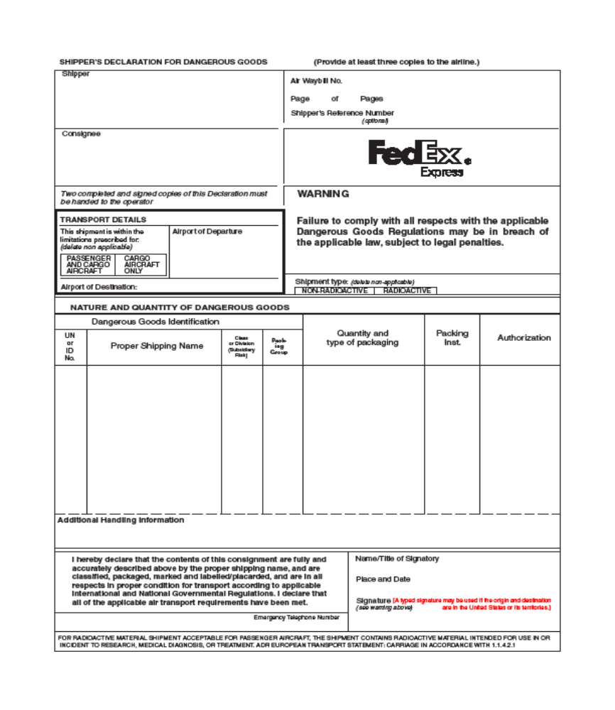
B
A (see Section VI for complete
explanation)
D
F
E
G
H
I
J
K
L
M
C
Appendix D

2814

Dr. Joe Smith
78 Research Ave.
Somewhere University
Seattle, WA 98046
1 of 1
XXX
Infectious substance
affecting humans (human immunodeficiency virus)

5 ml

6.2

602

1845

Dry Ice

9

3 Kg

904

Dr. Tim Jones
65 College Dr., XYZ University
Missoula, MT 59812
Tel: Dr. Jones, 406-555-9898
XXX
Nikki Jones, Biosafety Officer
Missoula MT, October 9, 2007

406-555-4127

Appendix E

HHS Select Infectious Agents, USDA High Consequence Livestock Pathogens/Toxins
and APHIS Plant Pathogens

KEY: 1 - APHIS Plant Pathogen, 2 - HHS Select Infectious Agent, 3 - USDA High Consequence Livestock Pathogen or Toxin, 4 - USDA-HHS Overlap Agent

Viruses

• African horse sickness virus ³
• African swine fever virus ³
• Akabane virus ³
• Avian influenza virus (highly pathogenic) ³
• Bluetongue virus (exotic) ³
• Camel pox virus ³
• Cercopithecine herpes virus (Herpes B virus) ²
• Classical swine fever virus ³
• Crimean-Congo haemorrhagic fever virus ²
• Eastern equine encephalitis virus ⁴
• Ebola viruses ²
• Foot and mouth disease virus ³
• Goat pox virus ³
• Hendra virus ⁴
• Japanese encephalitis virus ³
• Lassa fever virus ²
• Lumpy skin disease virus ³
• Malignant catarrhal fever virus (Alcelaphine herpesvirus type 1) ³
• Marburg virus ²
• Menangle virus ³
• Monkeypox virus ²
• Newcastle disease virus (velogenic) ³
• Nipah virus ⁴
• Peste des petits ruminants virus ³
• Rift Valley fever virus ⁴
• Rinderpest virus ³
• Sheep pox virus ³
• South American haemorrhagic fever viruses [(Junin, Machupo, Sabia, Flexal, Guanarito)]²
• Swine vesicular disease virus ³
• Tick-borne encephalitis complex (flavi) viruses [Central European Tick-borne encephalitis, Far Eastern Tick-borne encephalitis (Russian Spring and Summer encephalitis, Kyasanur Forest disease, Omsk Hemorrhagic Fever)] ²
• Variola major virus (Smallpox virus) and Variola minor Alastrim) ²
• Venezuelan equine encephalitis virus ⁴
• Vesicular stomatitis virus (exotic) ³

Prion
• Bovine spongiform encephalopathy agent ³

Toxins

• Abrin ²
• Botulinum neurotoxins ⁴
• Clostridium perfringens epsilon toxin ⁴
• Conotoxins ²
• Diacetoxyscirpenol ²
• Ricin ²
• Saxitoxin ²
• Shigatoxin and Shiga-like ribosome inactivating protein ⁴
• Staphylococcal enterotoxins ⁴
• Tetrodotoxin ²
• T-2 toxin ⁴

(Appendix E, continued)

Bacteria

• Bacillus anthracis ⁴
• Botulinum neurotoxin producing strains of Clostridium ⁴
• Brucella abortus ⁴
• Brucella melitensis ⁴
• Brucella suis ⁴
• Burkholderia mallei ⁴
• Burkholderia pseudomallei ⁴
• Candidatus Liberobacter africanus¹
• Candidatus Liberobacter asiaticus¹
• Coxiella burnetii ⁴
• Cowdria Ruminantium (Heartwater) ³
• Francisella tularensis ⁴
• Liberobacter africanus, Liberobacter asiaticus ¹
• Mycoplasma capricolu/M. F38/M. mycoides capri (contagious caprine pleuropneumonia) ³
• Mycoplasma mycoides mycoides (contagious bovine pleuropneumonia) ³
• Ralstonia solanacearum race 3 biovar 2 ¹
• Rickettsia prowazekii ²
• Rickettsia rickettsii ²
• Xanthomonas oryzae pv. oryzicola ¹
• Xylella fastidiosa (citrus variegated chlorosis strain) ¹
• Yersinia pestis ²

Fungi

• Coccidioides immitis ⁴
• Coccidioides posadasii ²
• Peronosclerospora philippinensis ¹

• Sclerophthora rayssiae var zeae ¹
• Synchytrium endobioticum ¹

Exemptions
• The following select agents or toxins are exempt:
• Any select agent or toxin that is in its naturally-occurring environment provided it has not been intentionally introduced, cultivated, collected or otherwise extracted from its natural source.
• Non-viable select agent organisms or nonfunctional toxins.
• Toxins under the control of a principal investigator, treating physician or veterinarian, or commercial manufacturer or distributor, if the aggregate amount does not, at any time, exceed the following amounts:
o 010 mg of abrin
o 0.5 mg of botulinum neurotoxins
o 100 mg of Clostridium perfringens epsilon toxin
o 100 mg of conotoxins
o 1,000 mg of diacetoxyscirpenol
o 100 mg of ricin
o 100 mg of saxitoxin
o 100 mg of shigatoxin
o 5 mg of staphylococcal enterotoxins
o 100 mg of shiga-like ribosome inactivating proteins
o 100 mg of tetrodotoxin
o 1,000 mg of T–2 toxin

(Appendix E, continued)

Genetic Elements, Recombinant Nucleic Acids, and Recombinant Organisms
• Nucleic acids that can produce infectious forms of any of the select agent viruses.
• Recombinant nucleic acids that encode for the functional form(s) of any of the select agent toxins if the nucleic acids:
• Can be expressed in vivo or in vitro; or are in a vector or recombinant host genome and can be expressed in vivo or in vitro.
• Select agents that have been genetically modified.

Restricted Experiments
• Experiments utilizing recombinant DNA that involve the deliberate transfer of a drug resistance trait to select agents that are not known to acquire the trait naturally, if such acquisition could compromise the use of the drug to control disease agents in humans, veterinary medicine or agriculture.
• Experiments involving the deliberate formation of recombinant DNA containing genes for the biosynthesis of select toxins lethal for vertebrates at an LD50 < 100 ng/kg body weight.

Appendix F

Exclusions for HHS Select Agents/USDA High Consequence Livestock Pathogens and Toxins

The Public Health Security and Bioterrorism Preparedness and Response Act of 2002 requires the United States Department of Health and Human Services (HHS) and the United States Department of Agriculture (USDA) to establish regulations regarding the possession, use, and transfer of select biological agents and toxins. In accordance with the Act, HHS and USDA published new regulations in the Federal Register on December 13, 2002 (67 FR 76886-76905 and 67 FR 76908-76938, respectively). The HHS regulations are set out in 42 CFR Part 73 and the USDA regulations are set out in 7 CFR Part 331 and 9 CFR Part 121.

The regulations in 42 CFR Part 73 and 9 CFR Part 121 establish a procedure by which an attenuated strain of a select biological agent or toxin that does not pose a severe threat to public health and safety, animal health, or animal products may be excluded from the list of select biological agents and toxins.

HHS received requests for exclusions for Yersinia pestis strains, Bacillus anthracis strains, Francisella tularensis subspecies novicida and Francisella tularensis subspecies holartica LVS.

USDA received requests for exclusions for Bacillus anthracis Sterne strain and Francisella tularensis subspecies holartica LVS.

Based upon consultations with subject matter experts and a review of relevant published studies and information provided by the entities requesting the exclusions, HHS and USDA have determined that the following attenuated strains are not subject to the requirements of 42 CFR Part 73 and 9 CFR Part 121 if used in basic or applied research, as positive controls, for diagnostic assay development, or for the development of vaccines and therapeutics.

However, an individual or entity that possesses, uses, or transfers an excluded attenuated strain will be subject to the regulations if there is any reintroduction of factor(s) associated with virulence or other manipulations that modify the attenuation such that virulence is restored or enhanced.

Attenuated strains of HHS select agents and toxins excluded:
• Coccidioides posadasii delta-chs5 strain.
• Conotoxins specifically excluded are: the class of sodium channel antagonist micro-conotoxins, including GIIIA; the class of calcium channel antagonist omega-conotoxins, including GVIA, GVII, MVIIA, MVIIC, and their analogs or synthetic derivatives; the class of NMDA-antagonist conantokins, including con-G, con-R, con-T and their analogs or synthetic derivatives; and the putative neurotensin agonist, contulakin-G and its synthetic derivatives.
• Yersinia pestis strains which are Pgm⁻ due to a deletion of a 102-kb region of the chromosome termed the pgm locus (i.e., delta-pgm). Examples are Y. pestis strain E.V. or various substrains such as EV 76.
• Yersinia pestis strains (e.g., T
• jiwidej S and CDC A1122) devoid of the 75 kb low-calcium response (Lcr) virulence plasmid.

(Appendix F, continued)

Attenuated strains of Overlap select agents and toxins excluded:

• Bacillus anthracis strains devoid of both plasmids pX01 and pX02.
• Bacillus anthracis strains devoid of the plasmid pX02 (e.g., Bacillus anthracis Sterne, pX01⁺pX02⁻).
• Brucella abortus Strain 19.
• Brucella abortus strain RB51 (vaccine strain).
• Coxiella burnetii Phase II, Nine Mile Strain, plaque purified clone 4.
• Francisella tularensis subspecies novicida (also referred to as Francisella novicida) strain, Utah 112 (ATCC 15482).
• Francisella tularensis subspecies holartica LVS (live vaccine strain; includes NDBR 101 lots, TSI-GSD lots, and ATCC 29684).
• Francisella tularensis ATCC 6223 (also known as strain B38).
• Venezuelan Equine Encephalitis (VEE) virus vaccine candidate strain V3526.

Attenuated strains of USDA select biological agents and toxins excluded:
• Highly pathogenic avian influenza (HPAI) virus, recombinant vaccine reference strains of the H5N1 and H5N3 subtypes.
• Japanese encephalitis virus, SA14-14-2 strain.

