Wildfire smoke exposure hurts learning outcomes
Pollution from wildfires is linked to lower test scores and possibly lower future earnings for kids growing up with more smoke days at school, a new study finds. Impacts of smoke exposure on earnings are disproportionately borne by economically disadvantaged communities of color.
- Facebook
- Twitter
- LinkedIn
- Email
By Josie Garthwaite
When wildfire smoke pollutes the air in schoolyards and classrooms, as it does with increasing frequency and severity across the country, it hurts not only children’s health but also their ability to learn and possibly their future earning power, according to new research from Stanford University.
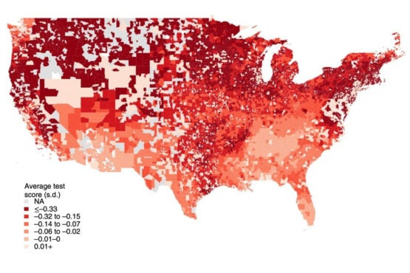
Exposure to fine particle pollution from wildfire smoke during the school day affects average test scores. In this map of the predicted effect on average test scores by district in a relatively high-smoke year, 2016, darker shades indicate a stronger impact. (Image credit: Wen et al. 2022, Nature Sustainability)
The new analysis, published Sept. 29 in Nature Sustainability, draws on eight years of standardized test scores from nearly 11,700 public school districts across six grades, as well as estimates of daily smoke exposure derived from satellite measurements.
The researchers found test scores in English language arts and math dropped significantly during school years even at low levels of smoke exposure, and that test-score impacts grew as students’ smoke exposure worsened.
The impact on test scores nearly doubled when students were exposed to heavy smoke during the school day compared to the weekend. Underscoring previous studies suggesting that air pollution impacts are particularly harmful for younger students, the study also revealed greater impacts for third to fifth graders compared to sixth to eighth graders.
“Previous research suggests that the natural barriers in their lungs are still developing and they have a higher rate of breathing relative to their body size,” explained lead study author Jeff Wen, a PhD student in Earth system science at the Stanford Doerr School of Sustainability. “This means that younger children may be more prone to smoke impacting their cognition in direct and indirect ways, such as increased asthma attacks that disrupt learning and lead to more school absences.”

Disproportionate impacts
The study builds on emerging evidence that exposure to air pollution can hurt cognition. “While test scores are an imperfect measure of student cognition, they are a common metric for evaluating student learning with relevance for long-term outcomes and opportunities,” the authors write. “This type of measurement allows us to compare test results in the same school district under different smoke conditions, and to do this for nearly all school districts in the U.S.,” Wen said.
Previous research has estimated a relationship between test score performance and future earnings. Based on those estimates, the authors estimate that American students’ exposure to wildfire smoke in just one year – 2016 – could lower cumulative future earnings nationwide by nearly $1.9 billion.
“The effects for any given student are pretty small, but once you start adding up the effects across hundreds of thousands of students who are exposed, they get pretty large,” said senior study author Marshall Burke, an associate professor of Earth system science at the Doerr School.
The new analysis shows that while all districts experience negative impacts per student, roughly 80% of the overall burden in terms of total lost earnings is borne by districts serving proportionately more students of color and more students who qualify for free or reduced-price lunch.
This is because there are more total students in these districts and because impacts per student are somewhat higher – a finding that should be understood to reflect “the possible effect of racist and/or discriminatory policies or attitudes on outcomes,” the researchers write, such as students having to attend schools that have received less investment in filtration. The disparity suggests that in the absence of intervention, “additional increases in future wildfire smoke exposure due to climate change will likely disproportionately harm these communities.”

Rethinking costs and benefits
Quantifying previously overlooked social costs of wildfire smoke – a rapidly growing source of exposure to toxic particle pollution that is expected to worsen under a warming climate – is not only an academic exercise. Rather, revealing previously hidden long-term costs at the population scale can help to motivate and justify more ambitious action to reduce emissions, smoke exposure, or wildfire risk through fuel management or other techniques.
“Reducing the risk of extreme wildfires is an important but monumental task. It’s going to take billions of dollars of investment over a lot of years,” Burke said. But at the classroom, district, or community level, investments in air conditioning and portable air filters can help keep people safe and allow students to learn with cleaner air when smoke plumes drift in.
“When we think about the impacts of wildfire smoke exposure and climate change, we can’t just limit our attention to the most obvious places where impacts could occur. We really need to look across society and think about all the sectors that could be impacted,” Burke said. “That helps us answer questions about how much we should invest in mitigating extreme wildfires, or in measures to protect students in school from poor air quality – and whether these are good investments relative to other things we can spend our money on.”
Burke is also a senior fellow at the Freeman Spogli Institute for International Studies, the Stanford Woods Institute for the Environment, and the Stanford Institute for Economic Policy Research. He is also deputy director of Stanford’s Center on Food Security and the Environment, a faculty research fellow at the National Bureau of Economic Research, and a member of Bio-X and the Wu Tsai Neurosciences Institute at Stanford.
This research was supported by the Robert Wood Johnson Foundation and Stanford Data Science.

Media Contacts
Marshall Burke, Stanford Doerr School of Sustainability: mburke@stanford.edu
Jeff Wen, Stanford Doerr School of Sustainability: jlwen@stanford.edu
Josie Garthwaite, Stanford Doerr School of Sustainability: (650) 497-0947; josieg@stanford.edu

