MAKING DOCUMENTARY
GS 591
Fall 2024
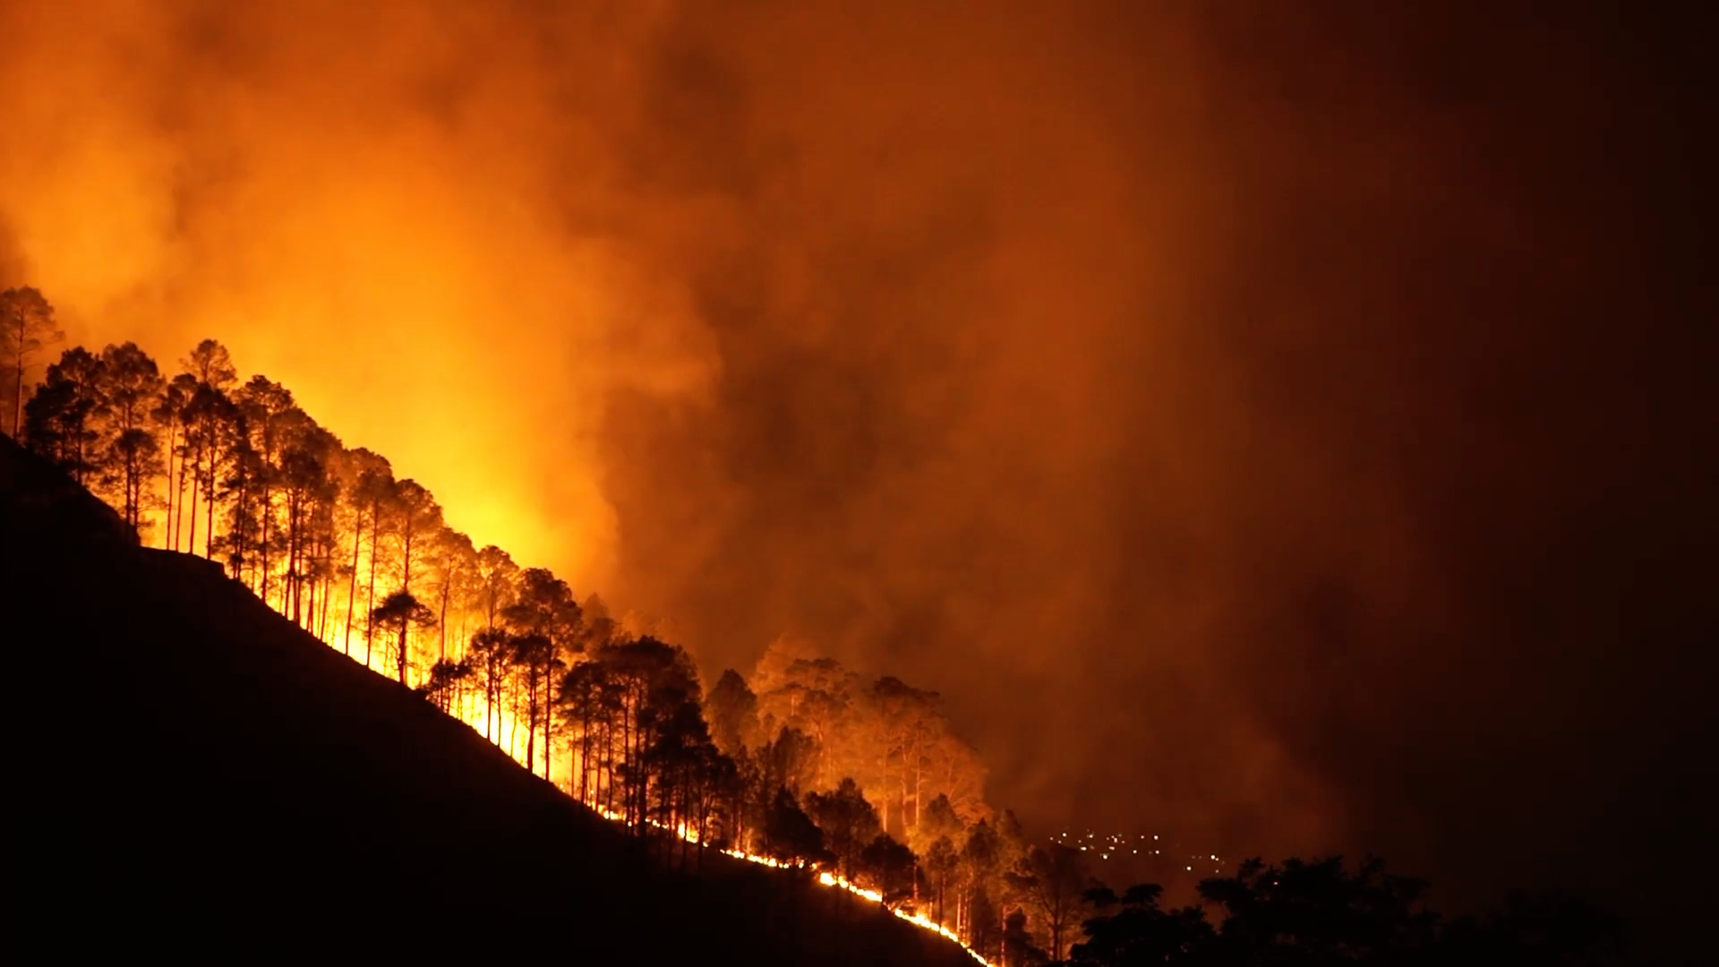
DON’T JUST WATCH DOCUMENTARY – MAKE ONE!

ATTENTION SCIENCE GRAD STUDENTS - Would you like to learn valuable production skills and incorporate a video component into your thesis or dissertation? A media project can expand access to your work and reach viewers inside and outside of academic circles. This class will teach you the basics of production and guide you through the process of making a short documentary.

There is no previous production experience necessary and students from all disciplines are welcome.
Instructors: Sean O’Brien and Antonio Torres
Fri from 9-11:40 a.m
For more information contact Sean O’Brien at (406)493-8342 or e-mail sean.o’brien@mso.umt.edu.

Examples of documentaries made in O’Brien’s previous classes:

https://umt.box.com/s/zhf2zsiccz4avrajmz2via510mv3gneq

https://youtu.be/it7cdais3E4

https://umt.box.com/s/nejua7bqeoby4rf4tw6kch5bcedh0q4w

https://youtu.be/ijA30VNGa1A

