FIRE DOOR FACT SHEET
A fire door is made of fire resistant material that can be closed to prevent the spread of fire. It includes the whole door assembly including the frame and hardware which is designed to hold back fire for a designated period and has been tested under certain conditions.
- Fire doors must not be blocked or locked when employees are inside.
- Fire exit doors are often held open for the convenience of employees and visitors, creating a significant fire hazard for all building occupants because of the break created in the fire barrier. Doors that are designed to be fire exit doors can be held open, but only if they automatically release when building fire alarms are activated.
- The fire door can feature a closer, which is a device that allows the door to close at a controlled rate of speed. However, the door must close automatically as soon as fire occurs. However, the door must be able to be actuated easily, allowing people to open it as they leave the building.
- OSHA regulations require that fire doors not be held open unless equipped with a device that releases the door upon activation of the fire alarm [29 CFR §1910.36 (a)(3)]
When Fire Doors are Needed:
- Where a door has an EXIT sign on or around it
- Where a door leads to exit stairwells and horizontal exits
- Where a door leads to a hazardous area such as flammable storage
- In general, where a door leads to a hallway or from one fully enclosed room to another
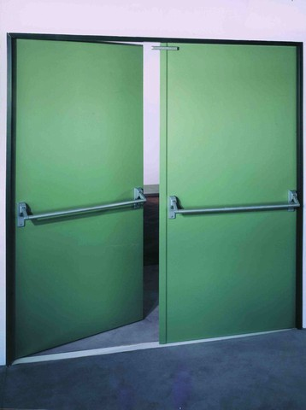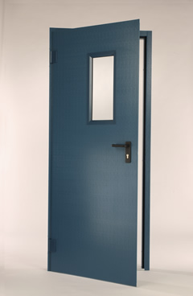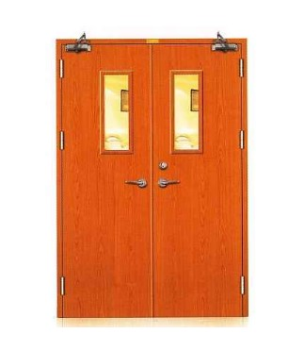
In the event of a fire, a propped open fire door will allow a fire to spread quickly causing more damage and putting peoples lives in greater danger. Only approved fire door retainers can be used such as a magnetic type which allow fire doors to be kept open for ventilation, but will close automatically when activated by the fire alarm. It is University policy that all fire doors be kept closed and not propped open for easy access or increased ventilation. If you notice a fire door propped open for whatever reason, you should close the door so it can function as originally designed.

