FACT SHEET REGARDING THE USE OF EXTENSION CORDS AND SURGE PROTECTORS
During our facility safety inspections, the Environmental Health & Risk Management Group has observed numerous violations in the use of extension cords, multi-plug adapters and surge protectors. The OSHA regulations and National Electric Code related to these devices is as follows:
- Extension cords are to be used for only temporary wiring for up to 90 days. An extension cord can be used when it is running directly from the appliance to the wall, but only as temporary wiring. Multi-plug adaptors used on the end of the extension cords or plugged into outlets are prohibited. Extension cords are not to be used to energize surge protectors from outlets. Increased cord length increases total electrical resistance and results in heat generation, increasing the chance for fire.
- Extension cords can be used for power tools, clamp lights, etc. for temporary power connections. The cord must have a grounding pin (3-prong-plug) or be polarized (one blade is wider than the other) and be in good condition. A cord with damaged outer insulation, crushed outer jacket, or exposed wires must not be used. Extension cords may not be fastened with staples or otherwise hung in such a fashion as could damage the outer jacket or insulation. Only one cord can be used for powering one piece of equipment. When using three-prong plugs, use only the proper grounding type of extension cord (one with three prongs). Polarized electrical plugs should be used only with polarized or grounding type extension cords. Portable electric equipment and flexible cords used in highly conductive work locations (such as those inundated with water or other conductive liquids), or in job locations where employees are likely to contact water or conductive liquids, must be approved for those locations.
- Surge protectors (SPs) are designed for use with a number of low-powered loads such as computers, peripherals or audio-visual components, protecting them from electrical surges or spikes. Underwriters Laboratory (UL) surge protectors need to be directly connected to a permanently installed branch circuit receptacle; they are not to be series connected (daisy-chained or piggy-backed) to other surge protectors. Daisy-chaining surge protectors can cause them to become overloaded, leading to their failure and a possible fire. Surge protectors were not designed to be used as additional outlets in lieu of properly hard-wired outlets.
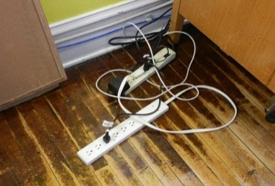 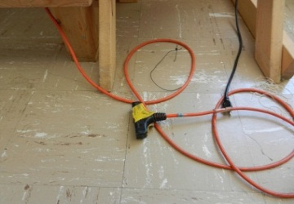 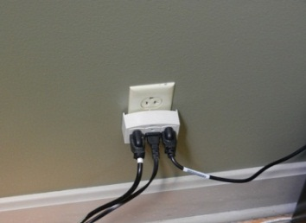
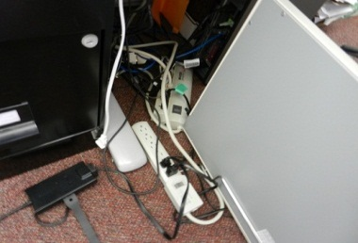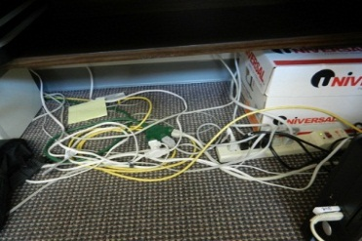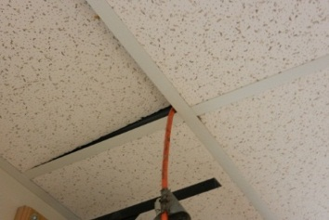
Photos of incorrect use of extension cords, multi-plug adapters and daisy-chained surge protectors
Surge protectors with cord length up to 25 feet are available through the Electric Shop. Please call Pat at the Work Order Desk – 6091.

