Free Sports Safety Resources

Phone Apps that can be Downloaded

- OSHA Heat Index
- Heads Up Concussion CDC
- Weather Bug
- My Lightning Tracker

Video Links
- The Game Plan: Managing On-Field Cervical Spine Injuries
  - https://youtu.be/yQe83lVD-bg
- The Game Plan: Sideline Assessment for Suspected Concussion
  - https://youtu.be/tou7biddi2M

Document Resources
- Montana REAP concussion packet
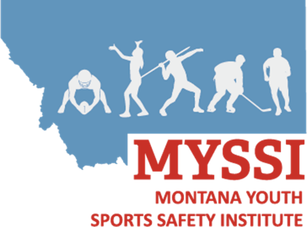
  - https://www.umt.edu/integrative-physiology-athletic-training/assets/documents/montana-reap-2020-final
- NATA Position Statements
  - https://www.nata.org/news-publications/pressroom/statements/position
- Korey Stringer Institute
  - https://ksi.uconn.edu/
- UW Sports Institute
  - https://thesportsinstitute.com/

