Getinge Assured SMART Pack

Mini – Bowie Dick Test Pack Indicator

Last Review Date: June 26, 2024
I. Purpose
Mini Bowie-Dick Test Pack is a single use device designed to detect the presence of residual air in pre-vacuum steam sterilizers operating at 132 C and 134 C for 3.5 minutes. The indicator card within the Mini Bowie-Dick Test Pack will demonstrate a uniform color change from purple to green when proper sterilization conditions are met and no air is present. The Indicator Card will change from purple (Fig.1) to green (Fig.2) when exposed to a steam sterilization cycle with acceptable vacuum cycles.
II. Responsibility
LAR staff is responsible for learning how to use and analyze the results of the test pack to check for mechanical air removal (vacuum) in both sterilizers. The sterilizers are located in HSB and South Skaggs animal facilities. The Bowie-Dick test is conducted once a month the first load of the day. SMART Packs are stored at room temperature in HSB009 cupboard.
III. Procedure
- Always check the expiration date on SMART Pack prior to use (located on top of test pack). Do not use expired test packs.
- Record SMART Pack in the logbook located near the sterilizer and enter load number on the outside of the Test Pack.
- Run a shortened cycle (omitting drying phase) to properly heat the sterilizer.
- Place the test pack flat on the bottom rack nearest to the drain. The test pack should read “This Side Up” when placed correctly.
- Select Cycle 7 (labeled SMART Pack). The cycle is for 3 minutes.
- Push autoclave door up to close.
- After the door has sealed, the green "Start" light will flash and the monitor will display "Standby."
- Press the "Start" button.
IV. Interpretation
- Remove the test pack from the sterilizer and allow pack to cool.
- Remove the indicator from the middle of the test pack and dispose of or recycle remaining pack materials.
- Examine the indicator immediately upon removal from the sterilizer, date the back of the test pack, and record the results in the SMART Pack record book in HSB008
- If no significant amount of residual air is present, the indicator will show a uniform green color change. If the indicator shows a purple color in the center, this indicates the presence of residual air.
V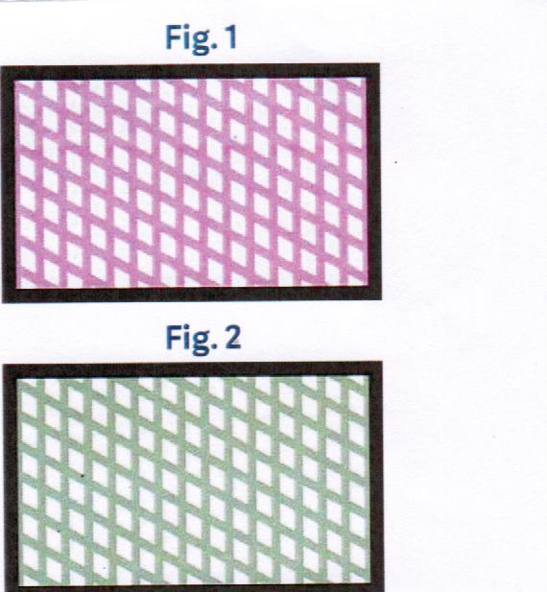

Safety Precautions
CAUTION: the test pack will be hot and should be opened carefully to avoid thermal injury

