Refined Rodent Handling Methods for Improved Animal Welfare

April 15, 2024

I. Purpose
The purpose of this SOP is to instruct LAR users (LAR staff and research personnel) on refined rodent handling methods with the intent to phase out tail-transfer methods for the benefit of animal welfare.
II. Introduction
Traditionally tail transferring has been the accepted method of movement of mice and rats between cages. Over time, as animal welfare and the 3Rs have evolved it has been demonstrated that refined handling techniques benefit rodents in the following ways:
- Reducing anxiety as measured by an elevated plus maze, social novelty test, open field test, and light-dark box test (shown in 10 papers including Hurst & West 2010)
- Reducing depressive-like behavior as measured by sucrose reward, resilience to negative events (Clarkson et al. 2018, 2020), forced swim test, and burrowing test (Sensini et al. 2020)
- Reducing chronic stress as measured by adrenal gland size (Clarkson et al. 2020)
- Increasing test reliability (Hurst & West, 2017)
- Improving physiological parameters such as improving glucose tolerance & reducing blood glucose & corticosterone (Ghosal et al. 2015; Ono et al. 2016)
- Increasing voluntary interaction with the handler (shown in 10 papers including Hurst & West 2010)
- Improving breeding as measured by larger pups (0.75g), more pups born (1), weaned (1.5 ), and longer breeding productive lifespan (20%; Hull et al., 2022).
For these reasons, UM’s LAR facilities will be transitioning from tail-transfer to refined handling methodologies.
II. Responsibility
Initially, LAR staff will be trained in refined rodent handling methodology beginning in the South Skaggs Facility, and once proficient, transition this methodology to all animal housing facilities on campus. With experience and continued use, the LAR staff will then begin instructing LAR users with the intent that tail-transfer will be phased out and disallowed in the LAR facilities.

III. Procedure

Please note: Refined Handling does not mean that mice cannot be handled by the tail once they are out of the cage.

Mice and rats may be removed from their caging by either Tunnel Handling or Cupping
- Tunnel Handling involves guiding mice into a tunnel to pick them up from their cage. The tunnel should be placed along the wall of the cage (not in the middle of the cage). Once lifted out of their cage via the tunnel they can be tipped out of the tube backward and scruffed for procedures, or slightly tipped forward to release the rodent into the clean cage. The 3r's Collaborative.

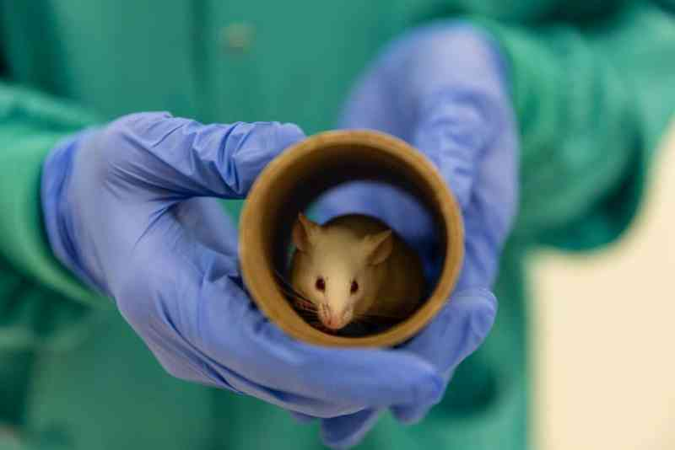

- Cupping involves picking mice up with cupped hands. It does not require any equipment but does require a bit more training of the mice. Videos that may be viewed: The 3r's Collaborative.
