Cage Washer: North Skaggs 034
Last Reviewed: May 6, 2024
I. Purpose
This standard operating procedure is designed to describe the proper use and maintenance of the cage washer in Skaggs Building 034, Getinge model VT-2850-CRW (serial no. 140323-01) in order to maintain sanitation of animal caging.

II. Responsibility
It is the responsibility of all LAR staff to know the proper use of the cage washer and to understand the different cycles, safety features, and routine maintenance procedures.

III. Protective clothing
- A dedicated lab coat and gloves must be worn when handling dirty animal contact materials
- When handling clean animal contact materials, wear scrubs (a clean lab coat is also ok) and clean gloves.

IV. Procedure
- Load dirty items into the dirty cage wash room (NSB 034)
- The cage washer is typically left on, however, if it’s turned off, turn it ON by flipping the switch below the display screen on the right side of the cage washer
- Load caging onto either the bedframe (AKA “bottlecart”) or the tree. While they are not in use, one is kept inside the cage washer, while the other is stored in NSB 030, located behind the clean side of the cage washer
- For the first load of the day, place a Thermolabel Temperature Strip on a piece of caging in the load (it stays on better during the cycle if it’s placed on a vertical surface)
- Push the load into the cage washer and close the door
- Press "Start" on the display screen
- Select the type of cycle you’d like to run using the touch-screen display:
  - Cages (Tree): mouse boxes, hoppers, microisolator tops, mouse racks
  - Test 2: (NA)
  - Heavy Soil: (NA)
  - Bottlecart (Bedframe): bottles, hoppers, lixits, cage card holders, etc.
  - Techwash: LAR carts
- Press the green "Start" button in the bottom right hand corner of the screen
- Record the load in the logbook which is located on the shelf above the bottle filler
- At the end of wash cycle:
  - Remove the Thermolabel Temperature Strip and place it in the cage wash logbook which is located on the shelf above the bottle filler in the dirty cage washroom
  - Unload clean items onto the metal shelving unit on the clean side of the cage washer located immediately to the right of the back hallway

V. Safety features
- Emergency STOP button on both doors of cage washer.
- Emergency cable inside the cage washer on both sides that turns off all power to cage washer.
- Cage washer will alarm for a few seconds before starting the cycle
VI. Monitoring cage washer chemicals
- Monitor chemical usage in 15-gallon drums per Pharmacal quarterly testing of pH, water hardness, and dosing; recorded in a notebook in HSB 009.
- Write the change date on the drum
- Notify facility manager when drum inventory is low

VII. Sanitation monitoring
- Thermolabel Temperature Strips (see SOP) - indicates that temperature of 180°F was achieved; use one strip in first cage wash load each day.
- Hygiena SystemSURE Plus (see SOP) - indicates that sanitation has occurred; clean caging is tested monthly.

VIII. Weekly maintenance at the end of each week
- Clean grates by removing from cage washer and spraying off with water.
- Clean debris from the drain under grates.

IX. Troubleshooting
- For specific cage washer problems, call Getinge Signature Services: (800) 950-9912
- For specific facilities problems, call UM Facilities Services: (406) 243-6091
- For detergent needs – Pharmacal Research Labs: (203) 695-4516
- Alert facility manager whenever technical difficulties arise

Appendix

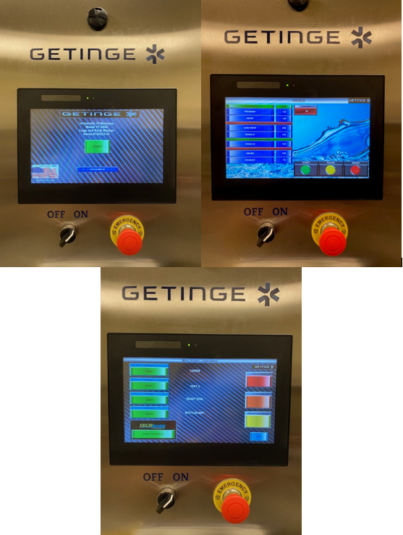
From top left to bottom right: Main display “Start” screen, cycle operations screen, cycle selection screen

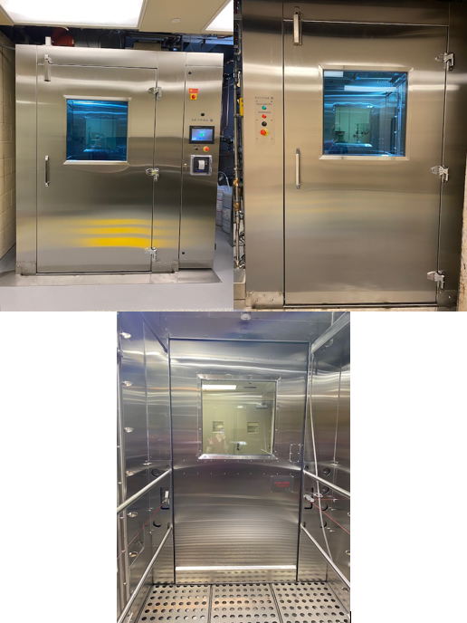
From top left to bottom right: Front of cage washer, back of cash washer, inside of cage washer (back of the clean side door)

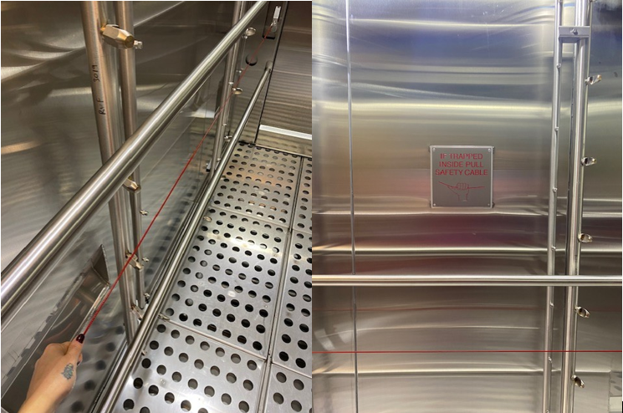
**Emergency safety cable and sign within the cage washer**

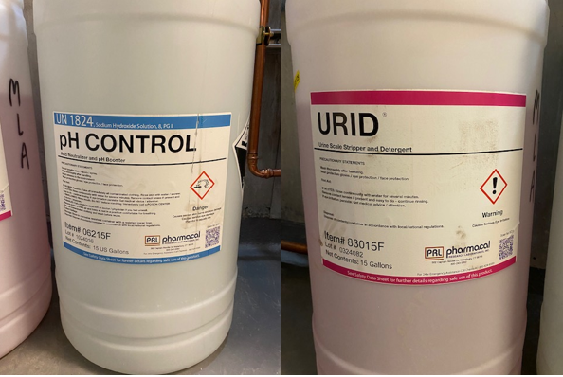
15-gallon barrels of cage washer detergents (pH control & urid)

