Betta splendens Husbandry and Care

Date adopted: June 5, 2024

I. Purpose/Scope
This Standard Operating Procedure (SOP) is designed to delineate the animal care protocols for Betta Splendens residing in stationary tanks within LAR’s Health Sciences Facility.
II. Policy
It is LAR's policy to meet or exceed all federal, state, and local regulations and guidelines and to comply with all institutional policies and procedures as they apply to the use of animals in research. Personnel must attend any applicable training in animal care and use, occupational health and safety, equipment operation, and SOPs prior to performing activities outlined in this SOP or working under the direct supervision of trained personnel.
III. Procedures
A. Water Quality
- Minimum Volume of Water for Each Housing Tank: Betta housing tank shall have a minimum of 5 liters of water to provide adequate housing space to ensure each fish has the ability to express natural behaviors
  - 25% of the tank volume is to be replaced weekly (Monday) with fresh water obtained from the well spigot in HSB 015 – and documented on the husbandry sheet
- Ph: Betta fish tolerate a Ph range of 5.0-9.0 but all attempts must be made to maintain the tanks at 7.0 (allowable range of 6.9-7.2)
  - Ph is to be tested weekly (Friday) and documented on the husbandry sheet
  - Any detected abnormalities in Ph are to be corrected immediately with a partial or full water change and documented on the husbandry sheet
- Salinity: Salinity is to be maintained between 0.1 – 0.3 ppt (alternatively, 1.000 – 1.002 specific gravity)
  - Using either a refractometer or a hygrometer - salinity will tested weekly (Friday) and documented on the husbandry sheet
  - Any detected abnormalities in salinity are to be corrected immediately with a partial or full water change and documented on the husbandry sheet
  - To increase salinity:
    - Measure the current salinity level
    - Calculate the amount of salt based on the desired salinity
    - Dissolve the salt in a separate container with water
    - Gradually add the saltwater to the tank, monitoring the salinity levels as you proceed
    - Repeat the process until the desired salinity is achieved
  - To decrease salinity:
    - Measure the current salinity level
    - Determine the desired salinity level
    - Prepare fresh, well water
    - Remove a portion of the tank water (10% at a time)
    - Replace the removed water with fresh water
    - Test the salinity levels after the water change
    - Repeat the process if necessary to achieve the desired salinity
e. Ammonia, Nitrite, and Nitrates will be tested weekly (Friday) utilizing a Fresh Water Master Test Kit (or similar commercial product) and results documented on the husbandry sheet
  - Results should fall within the normal range – as indicated on the test strips
  - Any detected abnormalities in water quality are to be corrected immediately with a partial or full water change and documented on the husbandry sheet
B. Water Temperature
- Water temperature is to be maintained at 28°C (+/1 2 degrees)
  - Water temperature shall be recorded daily for each housing tank and recorded on the husbandry sheet
C. Light Cycle
1. Betta fish shall be maintained on a 14:10 light/dark cycle
D. Housing Tank Cleaning
1. Housing tanks will accumulate algae to a detrimental level every 1-2 months and require a complete housing tank change-out
- The Betta fish shall be placed in a clean housing tank with fresh water and required enrichment
- The dirty housing tank will be placed in the HSB dirty cagewash room for LAR to process through the cage washer
- The complete housing tank change-out shall be documented on the husbandry care sheet
E. Enrichment Requirements
- Each housing tank shall have two types of plastic plants available
  - One shall adhere to the tank wall 2 cm below the water line
  - The second shall float on the surface and hang down into the tank
- When the plastic plants are visibly dirty with organic matter (algae):
  - Each plastic plant shall have all organic matter scrubbed off
  - Each plastic plant shall be soaked in a 5% bleach solution for 24 hours
  - After the bleach soak the plastic plants will be dechlorinated in a 10 g/l solution of sodium thiosulfate for 30 minutes
  - Finally, the plastic plants will be rinsed with clean water and dried on a rack
  - Once cleaned, decontaminated, rinsed, and dried the plastic plants shall be stored in a closed container in the housing room
F. Feeding
- Adult Betta fish (> 63 days post-fertilization) will be fed 8-10 pellets of commercial Betta Fish food per day
  - Feeding shall be documented daily on the husbandry care sheet
G. Daily Health Checks
1. Each day all fish will be inspected for health and well-being
a. Each fish will be visually assessed daily for health and well-being. Visual
characteristic to assess include:
- Inactivity and clamped fins
- Disinterest in food
- Floating to the top with difficulty in descending (buoyancy disorder)
- Laying on the bottom of the tank with difficulty in ascending (buoyancy disorder)
- Mottled spots on the fins or scales of the body
- Swollen abdomen
- Fin edges become jagged and/or become dull in color or transparent

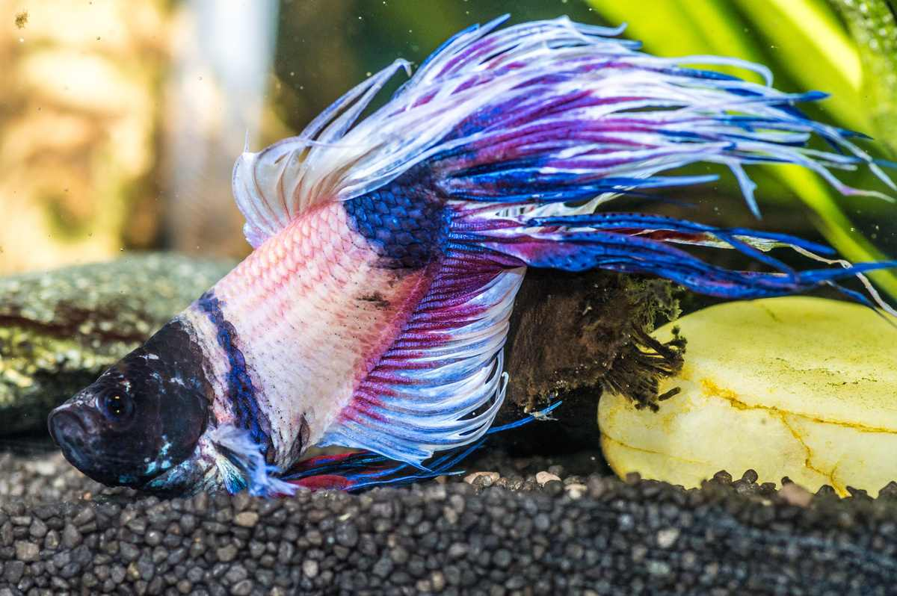
Figure 1. Sinking betta – buoyancy disorder
Figure 2. Betta with visible signs of “Ick”
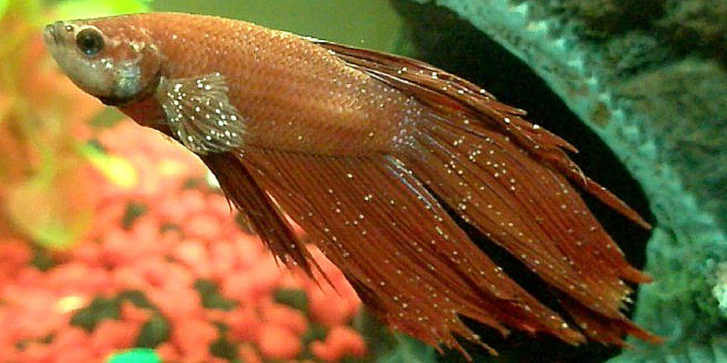

Figure 3. Betta fish with nonspecific signs of lethargy and fin clamping
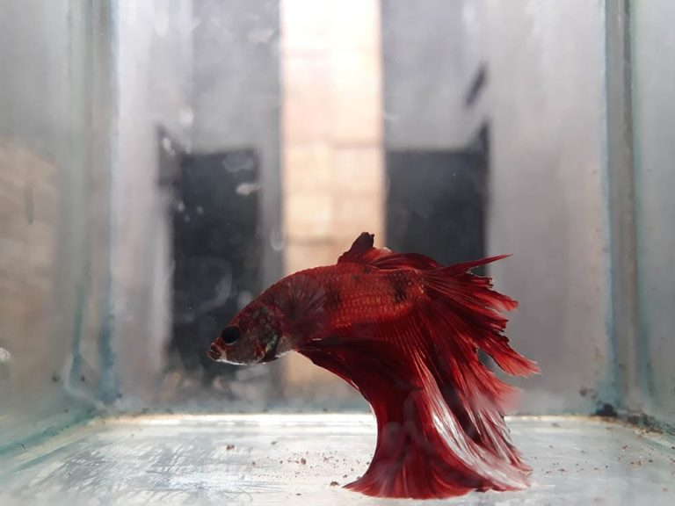

b. Should any abnormal signs or symptoms be observed the AV is to be alerted immediately
c. Daily health checks will be documented on the husbandry sheet

