Betta splendens: Common Diseases and Their Treatment

Date adopted: June 5, 2024

I. Purpose/Scope
The purpose of this Standard Operating Procedure (SOP) is to establish a systematic approach for the identification and treatment of common diseases affecting Betta splendens, commonly known as Siamese fighting fish or bettas. This SOP aims to ensure the health and well-being of bettas in our care by providing guidelines for early detection, accurate diagnosis, and effective treatment of diseases.
II. Key Objectives
- Early Detection: Implement protocols for regular observation and monitoring of bettas to detect any signs of illness or abnormal behavior at the earliest stage possible.
- Accurate Diagnosis: Standardize diagnostic procedures to identify common diseases affecting bettas, including but not limited to fungal infections, bacterial infections, parasitic infestations, and viral diseases.
- Effective Treatment: Outline appropriate treatment protocols based on the identified disease, ensuring the use of safe and effective medications or interventions.
- Preventive Measures: Incorporate preventive measures to minimize the risk of disease transmission and outbreak within betta populations.
- Record Keeping: Establish a comprehensive record-keeping system to track individual betta health, including observations, diagnostic results, treatments administered, and treatment outcomes.
- Continual Improvement: Encourage regular review and updates of this SOP based on emerging research, industry best practices, and feedback from experienced personnel to continually improve betta health management practices.
III. Responsibilities
This SOP applies to all personnel responsible for the care and management of Betta splendens in our facility.
- Aquarium caretaker(s)/PI staff are responsible for daily observation of bettas, early detection of signs of illness, and immediate reporting to the AV.
- The AV and LAR staff are responsible for overseeing the implementation of this SOP, providing necessary resources and training, and ensuring compliance with established protocols.
- The AV is responsible for confirming diagnoses, prescribing appropriate treatments, and advising on preventive measures and overall health management.
Adherence to this SOP is crucial to maintaining the health and welfare of Betta splendens in our care. By following these standardized procedures, we aim to minimize disease-related morbidity and mortality, promote optimal health outcomes, and enhance the overall quality of life for our bettas.
II. Policy
It is LAR's policy to meet or exceed all federal, state, and local regulations and guidelines and to comply with all institutional policies and procedures as they apply to the use of animals in research. Personnel must attend any applicable training in animal care and use, occupational health and safety, equipment operation, and SOPs before performing activities outlined in this SOP or working under the direct supervision of trained personnel.
III. Procedures
As long as bettas are housed singly in individual tanks no quarantine procedures are required as there will be no admixing of water between fish.
Bettas co-housed in tanks with dividers and freely sharing water require a quarantine of any newly acquired fish before adding them into a colony housing tank. Quarantine procedures are as follows:
- Newly acquired fish will be quarantined for at least one week
- Quarantined fish will be housed in a static tank (5 liters minimum) with a prophylactic dose of methylene blue (methylene blue is a chemical compound commonly used as a medication to treat a variety of conditions such as gill diseases, parasites, and fungi – dosage is 3 ppm, 5-day treatment course)
  - Only use of methylene blue that is specifically designed for aquarium use is allowable
  - Follow the directions from the packaging for dosing – typically this is 1 drop per one gallon
  - Mix 2-5 gallons of medicated water to be used for the daily water change

Figure 1. Example of aquarium Methylene Blue
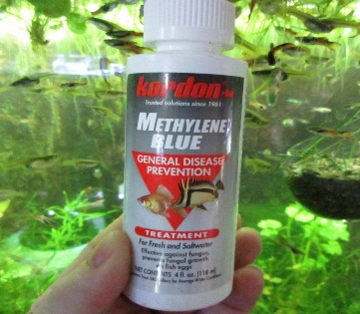
- Water will be changed daily with a 100% replacement volume of fresh water at system pH, salinity, and temperature.
- Quarantined fish are to be visually inspected daily for signs of infection or illness
- Daily inspections are to be documented daily on the husbandry sheet
- Any evidence of disease or illness is to be reported to the AV immediately
*Note: Methylene blue will stain surfaces and skin, care should be taken when mixing and using this product.*
IV. Common Betta Diseases and Their Treatment
If during daily health checks on bettas housed in LAR, any signs or symptoms of illness are detected, the AV is to be notified immediately. The AV will advise PI or LAR staff on probable diagnosis, order any specific diagnostic tests, or recommend treatment plans.
A. Velvet: Velvet, gold-dust disease, or rust disease is caused by a microscopic parasitic dinoflagellate of the genus Oodinium. Oodinium latches onto the fins, gill, or body of bettas and feeds on the nutrients present inside them. This causes the bettas to lose their color and are further dulled by a gold-like coating all over their bodies.
Symptoms:
- Gold or rust-colored coating on the body, fins, or gills
- Clamped fins
- Lethargy
- Inappetance or anorexia
Figure 1. Betta with Velvet
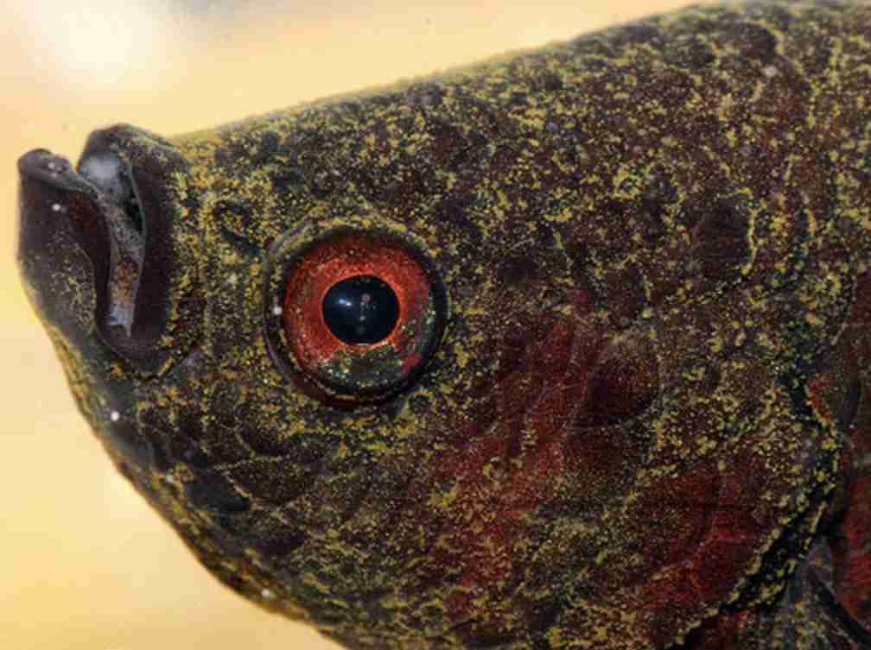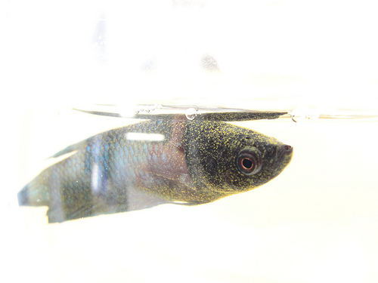
Treatment:
- The water is medicated with Proform C at a dose of 30 ul/L for a 5-day treatment – follow product directions for mixing and administering if different from the 30 ul/L.
- Water will be changed daily with a 100% replacement volume of fresh water at system pH, salinity, and temperature.
- Mix 2-5 gallons of medicated water to be used for the daily water change
- Daily treatment is to be documented on the daily or husbandry sheet
B. Fin Rot: Fin rot is a nonspecific term for lesions on fins caused by either bacteria or fungi. If bettas are co-housed they may nip and bite at each other’s fins, fin wounds may become infected and fin rot can occur.
Symptoms:
- Jagged fins
- Transparent or dull-colored fins
- Lethargy
- Inappetence
Figure 2. Betta with Fin Rot
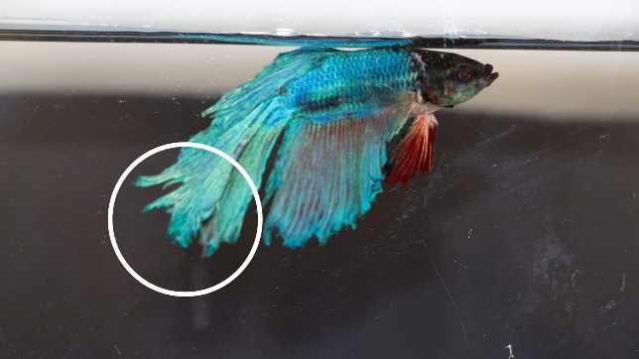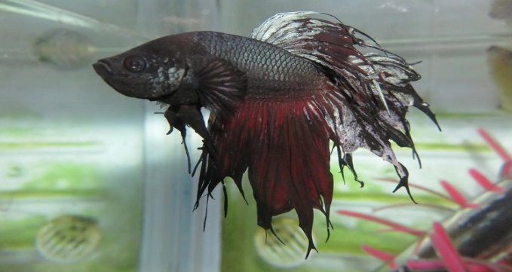

Treatment:
- Fin rot may be treated with the aquarium antibiotic Furan 2 (Nitrofurazone) at 46 mg/L for a 4-day treatment – follow product directions for mixing and administering if different from the 46 mg/L
- Water will be changed daily with a 100% replacement volume of fresh water at system pH, salinity, and temperature.
- Mix 2-5 gallons of medicated water to be used for the daily water change
- Daily treatment is to be documented on the daily or husbandry sheet
C. Mycobacterium spp.: Mycobacterium spp. also known as fish tuberculosis (TB), causes a tuberculosis-like illness in fish and can infect humans when injured skin is exposed to a contaminated aqueous environment. Human infection presents as a nodular granulomatous disease that can spread with distribution through the lymphatic system and is usually limited to the skin and soft tissues in immunocompetent patients.
Mycobacterium is a bacterial infection with nonspecific signs and can be difficult to distinguish from other illnesses. If signs of illness cannot be distinguished from other disease entities it may be necessary to euthanize a fish and send tissue samples to a diagnostic laboratory to evaluate infection with Mycobacteria.
Symptoms:
- Wasting of fins
- Dull coloration
- Lethargy
- Inappetance
Treatment:
- Fish with suspected Mycobacteriosis (if co-housed) are to be isolated to prevent spread to co-housed fish
- There is no approved treatment for Mycobacteriosis and the fish should be euthanized either after diagnostic confirmation or upon presumptive diagnosis
D. Ich/Ick: Ich is a protozoal parasitic disease (caused by Ichthyophthirius multifiliis) that is highly contagious to other fish. Poor water quality, stress, physical trauma, infection, or introducing a contagious tank mate can predispose to contracting Ich.
Symptoms:
- Small white dots that resemble sugar granules on the body, fins, or gills
- Rubbing against object in the aquarium (causes obvious itching)
- Lethargy
- Inappetance/anorexia
- Tears in fin or scale damage due to itching
- Clamped fins and labored breathing
- May be fatal without treatment

Figure 3. Betta with Ich

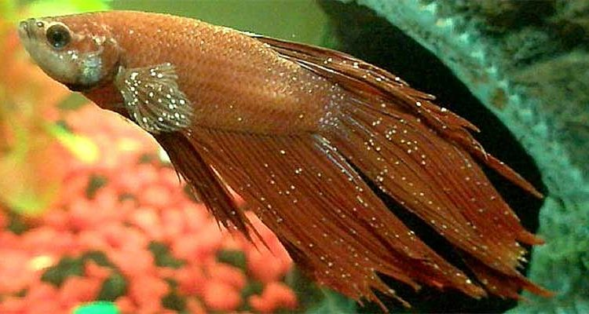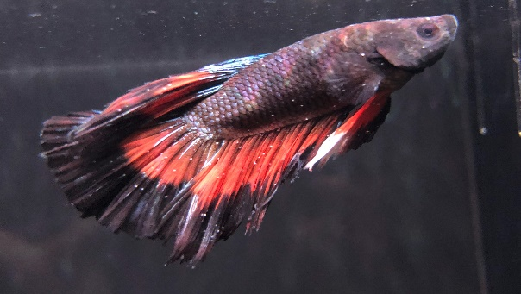

Treatment:
- Move the infected fish to a hospital tank if they are co-housed
- Increase the water temperature slowly until it is 27 – 30° C (81-86° F) if not already in that temperature range. Ich parasites prefer colder water which leads to increased reproduction.
- Warm water holds less oxygen, so consider adding an airstone if the tank is not already so equipped. Increased oxygen can boost betta fish's immune systems.
- Treat the tank water with Rich Ich Plus™ or ICH-X™as directed on the product
Figure 4.
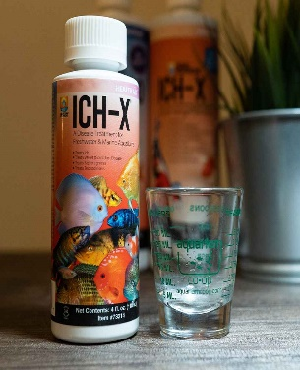
5. Perform daily water changings of 25-50% to reduce high medication levels and remove Ich trophonts (the protozoal stage when the parasite is attached to the betta, feeding and visible) and tomites (the protozoal stage when the parasite releases from the betta, falls into the tank and attaches to gravel or tank décor and begin reproductive stage)
6. Continue the duration of treatment with medication according to the directions. Ich protozoans are only vulnerable to medications two days out of their seven-day lifespan, so continue even if Ich appears to be gone
E. Buoyancy Disorders: Fish with buoyancy disorders (swim bladder disease) will either float toward the surface, or their tails may sink to the bottom so that they swim vertically in the water. Buoyancy disorders may be caused by overfeeding, constipation, shock, infection, or parasites.
Symptoms:
- Floating at the surface and unable to descend
- Floating at the bottom of the tank and unable/or has difficulty ascending
- Lopsided swimming
- Swimming upside down
- Floating on their side
- Clamped fins
- Lethargy
- Inappetance/anorexia
Treatment:
- Overfeeding/Constipation:
Fast the betta for 1-2 days, and gradually increase the heat a couple of degrees (27–30° C [81-86° F]) to speed up metabolism. If after 2 days there’s no change, feed your betta daphnia (a frozen food obtainable from pet store).
- Parasite/Bacterial Infection:
Move the betta to a quarantine tank. Dose the tank with the appropriate medication for either a parasites or bacterial infection (as per AV recommendation)
- Other nonspecific treatment:
Mix one tablespoon of commercial marine salt in a gallon of well water (or as directed on packaging). Add the betta to the water and let them swim in treated water for 10-15 minutes. Monitor their behavior throughout, and then place them back in their tank. If the betta seems in distress while in the salt-treated water place them back in their tank immediately

References:
- Care and Use of Betta Fish in the Laboratory. https://www.ncbi.nlm.nih.gov/pmc/articles/PMC9334006/pdf/cm2022000169.pdf
- Betta Care Fish Guide. https://www.bettacarefishguide.com/swim-bladder-disease-in-bettas/
- Betta Fish Velvet Disease: Symptoms, Treatment & Prevention. https://fishlab.com/betta-velvet/
- Swim Bladder Disease in Bettas: Symptoms, Causes, Treatment.

https://bettafish.org/diseases/swim-bladder-disease/
- Betta Fish Fin Rot: Symptoms, Causes and Treatment. https://bettafish.org/diseases/fin-rot/

